APPENDIXES
Appendix 1 Students’ Mind Mapping

Group 1
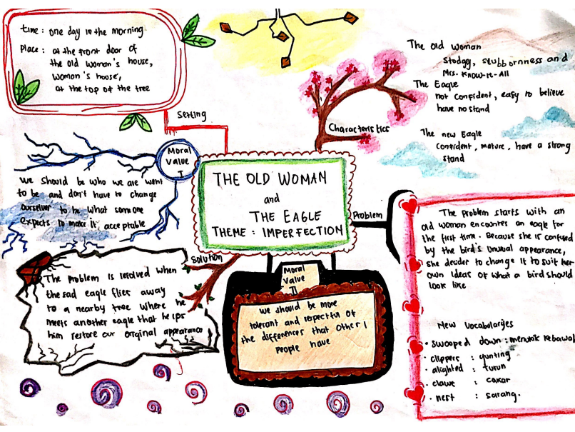
Group 2
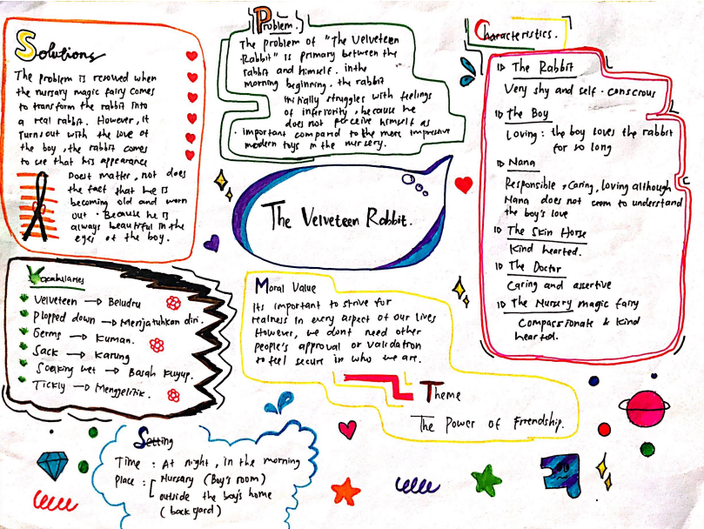
Group 3

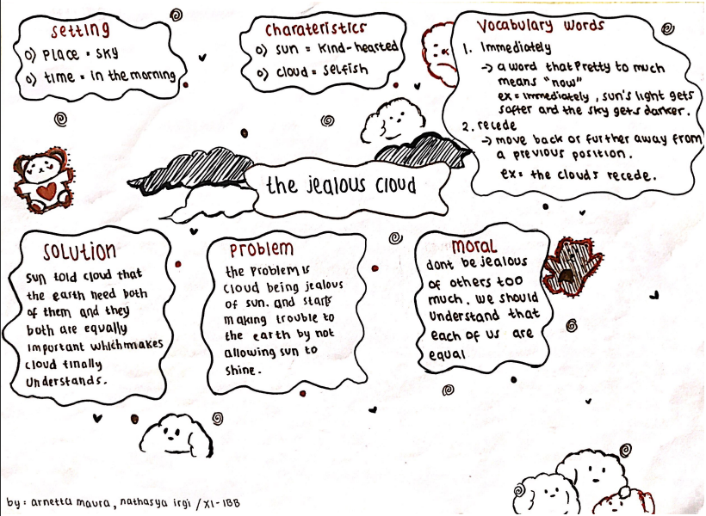

Group 4

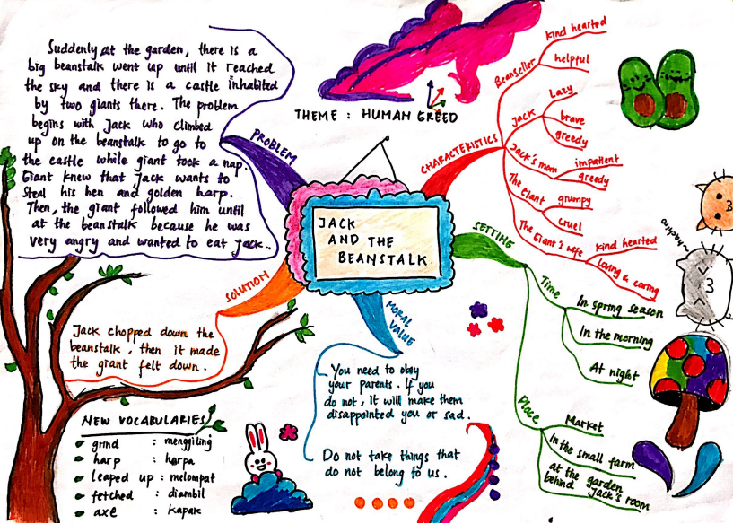
Appendix 2

The Implementation of REAP Strategy Combined with Mind Mapping
in the Teaching and Learning Activities
Activities |  |  | Teacher | Students
Reading | Scientific Approach | REAP
Pre-Activities | Observing  Questioning |  | The teacher stimulates the students’ background knowledge by asking several questions about the narrative text. | The students answer several questions about narrative text based on their background knowledge.
 |  |  | The teacher divides the students into some groups. In each group of students consist of three or four people. | The students divided into some groups. In each group of students consist of three or four people.
Whilst-Activities | Collecting data  Associating | Read  Encode  Annotate  Ponder | The teacher explains the material of narrative text (definition, social function, language features, and generic structure) through a LCD projector. | The students pay attention from what has been delivered by the teacher through a LCD projector.
 |  |  | The teacher asks the students to read the text thoroughly in order to find the author’s theme and the title of the text by writing it in mind mapping. | Students read the text thoroughly in order to find the author’s theme and the title of the text by writing it in mind mapping.
 |  |  | The teacher asks the students to explore the idea in order to find the main idea and difficult or new vocabulary in the text by writing it in mind mapping. | The students can explore the idea in order to find difficult or new vocabularies in the text by writing it in mind mapping.
 |  |  | The teacher encourages the students to write down the important point or main events of the text in each paragraph by using mind mapping. | The students are requires to write down the important point or main events of the text in each paragraph by using mind mapping.
 |  |  | The teacher asks the students to find the moral value by talking and discussing with the group members. Then, present to another group about what they just made in mind mapping using their own words. | The students are asked to find the moral value by talking and discussing with the group members. Then, present to another group about what they just made in mind mapping using their own words.
Post-Activities | Communicating |  | The teacher asks the students to review the material they learnt. The goal is to convince the students’ comprehension of the text. | The students are asked to review the material they learnt. They are also allowed to provide some suggestions and ideas about the material.

Appendix 3 Observation Checklist

Observation Report of Teaching and Learning Reading Comprehension Process
through REAP Strategy Combined with Mind Mapping
Subject | Pointer(s) | Yes | No | Note
Pre activities  (teacher) | Teacher greets the whole class
 | Teacher checks the students attendance list
 | Teacher gives motivation
 | The teacher stimulates the students by exploring the students' background knowledge by asking them several questions.
 | The teacher explains the task to be discussed about REAP strategy (Read, Encode, Annotate, Ponder) before the students are divided into groups.
 | The teacher organizes the students into mixed ability groups same ability groups as need be.
Whilst activities  (teacher and students) | The teacher explains mind mapping outline with the main events of the text in each paragraph (orientation, evaluation, complication, resolution, and coda) and the main idea.
 | The teacher asks the students to read the text thoroughly in order to find the author’s theme and the title of the text by writing it in mind mapping.
 | The teacher asks the students to explore the idea in order to find the main idea and difficult or new vocabulary in the text by writing it in mind mapping.
 | The teacher helps students to learn difficult or new vocabulary which they find.
 | The teacher encourages the students to write down the important point or main events of the text in each paragraph by using mind mapping.
 | The teacher supervises the discussion in the groups so as to encourage and help students in difficulty.
 | The teacher reminds the time of the students.
 | The teacher asks the students to find the moral value by talking and discussing with the group members for presenting to another group about what they just made in mind mapping using their own words.
 | The teacher gives students feedback about their performance.
 | The teacher asks students to answer the task which already been prepared by the teacher to check students' understanding.
Post activities  (teacher) | The teacher evaluates and concludes the lesson and closes the meeting.
Students’ Problems
Students’ Problems | The students did not have good vocabulary mastery.
The students have difficulty to decode the word and
sentence
 | The students have difficulty in speed of reading
 | The students have difficulty in speed of reading
 | The students have problems of inference making.
 | The students have problem to working memory the text.

Appendix 4 Narrative Presenting Rubric

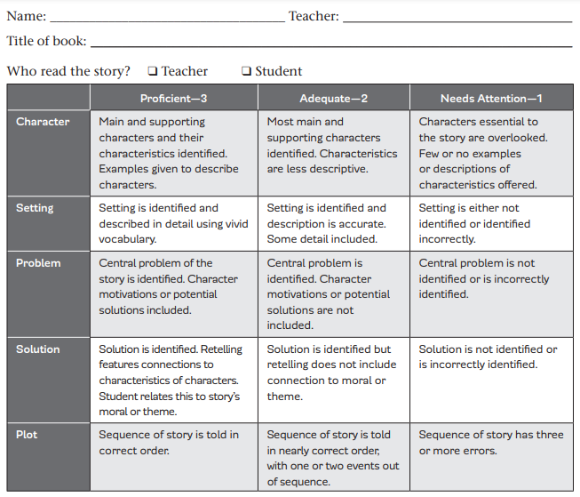
Mind mapping in the box below, then score quality of the presenting
