SKILLED AT WRITING CHILDREN'S STORIES WITH SMARTPHONE APPLICATION
(Case Study in Paud Terpadu Bunda Tami Tasikmalaya)

Ayi Maulida
IKIP Siliwangi
bundaay.69@gmail.com

ABSTRACT
This article is based on the research that aims to improve the skills of teachers in writing stories using the application of Art Filters and Pictsay Pro on smartphone as a helper for teachers to make stories to PAUD students. The research method is done by using Research and Development approach (R & D), i.e. research that is followed up by producing the product and testing the effectiveness of the product. This research involves teachers in PAUD TERPADU BUNDA TAMI and also the students. The research procedure consists of two stages, the first is introduction and the second is model development. Data were collected by using observation; interview, documentation, questionnaires and expert validation test, and the results were analyzed using qualitative analysis techniques. Research shows that there is an increase in teachers' skills in writing the story, because the existence of these products provide new ideas and to develop a story with regard to the principles in PAUD development, such as holistic, contextual, meaningful, and fun. Student activeness in story learning also increased, this is because children can be the subject of the story so they feel enthusiastic and has a high interest to listening, asking and telling themselves in an event or somewhere according to the theme of the learning process.
Keywords: Writing, Writing children's story, Smartphone Applications

- INTRODUCTION
The rapid development of human civilization today, one of which is caused by the process of delivering information that went so smoothly. The development of information has now reached all aspects of life in society. Studying information technology is one of the things that need to be done by communication activists because communication cannot be separated with the development of information technology. One of the forms of information technology is a smartphone. Smartphone is a mobile phone that has the ability to use and functions that resemble computer. This form of information technology application is in great demand by the public. Smartphone is a mobile phone with a sophisticated portable operating system equipped with a computer-like operating system. Smartphones can implement various forms of multimedia just like computers, the advantage of a smartphone is that it has a high mobility and also can be operated more effectively. Almost in all areas of life did not escape from the utilization and application of information technology. Certainly, the technology is applied with different types of processed information. These fields are in the field of education. The field of education can also feel the tremendous benefits of the existence of this information technology. Various learning models can be done easily and quickly. Besides, this information technology also can help the learning process or used as an educational media.
Usually in a smartphone there is a software application that is generally known as a system or program that has a function as a digital facility that helps the users to finish their task or job such as words processing, images, numbers, sounds, and so on. Not only that, it has so many functions that are divided into several fields or categories such as entertainment, business, education, etc.
Swafoto or more often known as selfie has now become the lifestyle of the society. This is proved by the emergence of a smartphone with a sophisticated front camera to software that can manipulate images as an additional feature. In addition, the developers are also competing in creating camera applications as well as photo editing applications to make the images stunning. One of them is Art Filter Photo Editor & Selfie Camera and Picsay Pro. Art Filter Photo Editor & Selfie Camera allows users to create cartoon and pencil sketches and pop artwork with a stunning pop art filters. Meanwhile, Pictsay Pro application that is created by Shinycore is very useful for those who like to do photo editing. In order to use this application there is no different from most other editing photo application. Users are asked to take a picture that is already available in an album or take a picture directly. Furthermore, the user can select various options such as color settings, put stickers on the image or add other photos on the image. Moreover, the user can add text to every image that they want. Through these various applications, all phones now seem to be transformed into such a photographer. The user of these applications is dominated by women. This is because more women spend their time to play social media that will lure them to style (exist) with a variety of photos either pictures of themselves or other images.
In the field of education, this application can be used as educational media. For example, writing children's story. Writing is one of the language skill which aims to express the ideas, and feelings in writing or into the symbols of sound. By writing, a person will experience the thought processes to express their ideas more broadly. Writing is related to one factor of the development of free thinking, based on the underlying experience. Such experience can be gained through reading, listening and discussion. Besides, writing can also be a productive and an expressive activity. However, the fact of writing children's stories is often becomes a hard and difficult thing to do, especially for novice writers, including PAUD teachers. In fact, the stories are very identical to their lives in order to develop their imagination and broaden their horizon and knowledge. Levita Rachmawati (2013), said that mastery of a short story writing technique will help someone to understand and know how to write a short story well.
Tarigan (2008: 186) asserted that learning to compose has not been done well in school. Because it lies only in the way the teachers teaches. Generally less variation, less in stimulating, and less in frequency. Discussion of student essay less implemented teacher.
For that purpose, this research aims to improve the skills in writing stories by using the application of Art Filter and Pictsay Pro on smartphone as a supporting media for teachers to make stories for children. With these applications, teachers are expected to be motivated for more creative in order to make a learning media for their students. This article presents the results of research in the form of storybook products through the use of applications on smartphones.

- THEORETICAL REVIEW
Smartphone Application (Art Filter Photo Editor & Selfie Camera)
Art Filter Photo Editor, Cartoon Photo & Selfie Camera is an application from Google Play that could make cartoon and pencil sketch and pop artwork with a good pop art filter. Art filters transform photo objects into artwork using their artificial neural network algorithms. Photo editor with cartoon filter using pencil sketch effect, photo filter and filter is a mixing from self-beauty and self-glamour camera. Art Filter is one of the stylish photo effect collections.
Other than that application, there is also an application named Pictsay Pro which is an android photo editing application that is easiest to use. The application that is invented by Shinycore has a very small size that is less than 2Mb. For that reason, this application can work very fast, and it can be used on all versions of android. Besides its has very light memory, this application is very simple to use too. After adding the filter section, android or smartphone users can add so many styles via text and animation according to the moment that contained in the photo.
The Understanding of Writing
Tarigan (2008: 21) states that writing is to derive or represent graphic representations depicting a language that a person understands, so that others can read the graphic symbols if they understand the graph language.
Meanwhile, according to (Fajri, 2005) writing is part of the language in written form in order to express the idea to the readers (Fajri, 2005). The purpose of writing is: (1) Conveying a thought or idea to the reader; (2) Delivering information about a story to the reader; (3) Providing entertainment to the reader; (4) Influencing or inviting the reader through writing.
Based on its purpose, writing can be divided into several types, which are scientific writing and non-scientific writing (fictional). Meanwhile, this research will be focused on improving the ability to write fiction story (non-scientific). In non-scientific writing, the language that is used is informal language and it and can be a mixture of fiction (non-scientific) and ordinary stories. Sometimes the characteristics of the story are logical and sometimes illogical.
Writing narrative stories is a fictitious (imaginary) storytelling or stories that come from self-experience. In the narrative stories, there is usually a continuous story that is presented with a clear description of the characters in the story, the storyline and the scene as a whole. Therefore, as if the reader can experience the event directly delivered by the author through the reading (Fajri, 2005: 952).
According to Hermowo (2002:38), writing is about the deepest thoughts and feelings about an event or experience which will even make the mood better with a positive outlook, and make health even better.

Writing Fiction Stories
To begin writing a story, every writer has different technique writing. When starting to write a fictional story, let this be a continuation task, find out how much there is to know about the materials that will be used to guide the story. If in the story it tells the events completely based on memory, without wishing to make things up, do not even want to exaggerate and embellish or describe in detail, then the writing is a non-fiction story. However, if the text is contrary to the above, then the writing is a fictional story (Hernowo, 2003).
According to KBBI (Big Indonesian Dictionary), fik · si n 1 Literature, fictional stories (novels, novels, etc.); 2 fictitious; fantasy; not based on reality; 3 statements that are based only on delusions or thoughts.
Fictional stories are more like lies or fiction. Writer can start the story with something real, but for a specific purpose (so as not to be caught, considered cheating and earning money) so that the author at least change one important point in the story. This is a good thing for writers as a place to express their ideas so they can be a whole story.

The Benefits of Writing Stories for Teachers
The ability or mastery of fiction wriring techniques is helpful, even important for someone skilled at writing stories, expressing ideas, criticism, petition, moral values and educational values. Especially someone who is involved in education, to deliver his/her massages, and then they can do it through stories that have been written.
The Implementation of Art Filter Photo Editor & Selfie Camera and Pictsay Pro Application in Making Stories
In Big Indonesian Dictionary (1984: 283) mentioned that the photo is a portrait image. Sudjana & Rivai (2002: 71) states that photo media is one of the learning media that is not projected to be observed and used for the purpose of individuals, small groups or large groups. Meanwhile, according Sadiman, Raharjo, & Haryono (1990: 29), photo media is a medium that is often used because a photo more express than a thousand words. According to Susilana and Riyana (2008: 15), silent image media is a visual media in the form of images produced through the process of photography. This media type of image is a photo.
Art Filter Photo Editor & Selfie Camera relies on images as a media in the learning process to children. These images or objects can be one of the main factors in the learning process. In this application, each student can be the object or character in the story. Students can be photographed with a variety of styles, then use a suitable background or image, and then the photo can be merged through the editing process and made into a quality art. The story can be arranged in advance with the existing theme, so before the learning process begin the teacher has prepared an image that will be displayed either in the form of a card / flashcard or in the form of a large-size carta and in the form of cartoon and pencil sketches and pop artwork and a good pop art filter. Meanwhile, the Pictsay Pro application can be used to add story text to images that have been in the process of editing. So the shape of the story can be made like a comic.
- METHODS
This research is conducted by using Research and Development (R & D) that is research which is followed up with the development and dissemination. Research development will produce the product and will test the effectiveness of the product (Sugiyono, 2011). The research procedure consists of two stages, the first is introduction and the second is model development. In the introduction, data collection was done to obtained an overview of what teachers needed and also the implementation of writing skills development in writing children stories for PAUD students. Furthermore, an analysis of story writing skills was conducted. From the results contained in the introduction, used as a foundation for composing a model of developing the ability to write using smartphone applications that are Art Filter Photo Editor & Selfie Camera and Pictsay Pro. After that in the assessment phase the skills of writing is validated by the validators (experts and teachers) then it should be revised based on the suggestion that are given by the validators. The model development that already revised then tested in the field, which is implemented in teaching and learning activities in kindergarten.
The research was conducted in PAUD BUNDA TAMI Tasikmalaya District for 1 month starting from introduction to smartphone application development. The introduction was done to the subject of study of "PAUD TERPADU BUNDA TAMI" teachers to gain the data about the importance of improving writing skills for teachers. Determination of "early childhood" was chosen as the subject of the research conducted by purposive sampling that is the technique of determining the sample because the researcher has a certain consideration or goal which is adjusted to the purpose of the research.
Considerations of sample determination are: (1) Attitude of openness to learning innovation and willingness to collaborate both from teacher and head of "PAUD" which have been selected; and (2) The condition of the school is adequate both in terms of facilities and facilities that will be used for model development. Research subjects in field trials are teachers who collaborate as learning implementers consisting of two "PAUD" teachers and “PAUD” students themselves.
The methods used to collect data are field observation, interview, document review, expert review (cf. Richey & Klein, 2007) and questionnaire. In the introduction study, for 2 (two) weeks, data were collected by using observation method, interview, document review, and questionnaire. Supporting instruments for collecting research data include: observation guides, field notes, audio recordings, documentation photographs, documents, and research scale. The data in this research uses quantitative and qualitative research. The quantitative data generated from a questionnaire about the conditions and needs of the teachers at the beginning of the study. Meanwhile, the qualitative data is generated from interviews, observations and document studies on the introduction and data development process. Quantitative analysis techniques are used to process the data at the beginning of the introduction. The results of the questionnaire were analyzed by percentage and described in qualitative. Field test data is a result of model implementation in the field that is analyzed by using qualitative analysis technique of flow model (Miles & Huberman, 1992 via Sugiyono, 2011). Analytical activities include: data reduction, data presentation, conclusions and verification.
- RESULT OF THE RESEARCH AND DISCUSSION
The results of the introduction to the conditions and needs of the teacher indicate that all teachers prepare the plan in the form of Rencana Pelaksanaan Pembelajaran Mingguan (RPPM) and Rencana Pelaksanaan Pembelajaran Harian (RPPH) before implementation begins. In preparing the plan, teachers do not experience difficulties. However, the difficulty experienced by teachers in developing children's story writing skills is to make stories as interesting as possible for children.
Observations were made during the story-writing lesson that was held in the PAUD TERPADU BUNDA TAMI. In addition, interview sessions were conducted with teachers by knowing the results of the actual conditions that occur in the skills of writing stories to children. From this initial observation there is also a problem in the way of telling the story to the children.
Based on the result of the first observation, researcher found out that teachers are actually lacking in their skill of writing stories, it can be seen from the methods and the use of media is monotonous and without involving students so that children tend to just listening, speaking and reading. Therefore, researchers collaborate with classroom teachers to obtain a solution to resolve the issue. After researcher and teachers held a discussions, it was finally agreed that the use of the Art Filters Photo Editor & Selfie Camera and Pictsay Pro application as a media to enhance students' attractiveness while developing and improving story-writing skills for teachers.
Furthermore, researchers try to socialize how to develop the stories with both applications by asking teachers to download both applications. After that, each teacher is asked to determine the theme of the story as well as designing the concept of the story to be presented. If the concept has been properly arranged, then the teacher does a photo shoot of the student with a pose that has been adjusted with the dialogue in the story that has been designed previously. After that do the editing using both applications.
Besides that, researcher conducted interviews and questionnaires with teachers regarding the result product from Art Filters and Photo Editor Selfie Camera and Pictsay Pro application, feedback submitted by teachers turned out to be very responsive. They were impressed with both applications that could support a story, which they knew beforehand that these applications have been mostly only used for selfie and editing on a photo to produce an artistic image just as a pleasure.
After that the researcher together with the teacher designed a plan to practice making the product with the children. Here are some examples of results from the Art Filter Photo Editor & Selfie Camera and Pictsay Pro application.
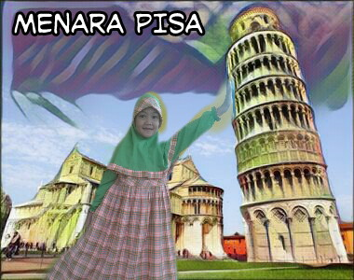
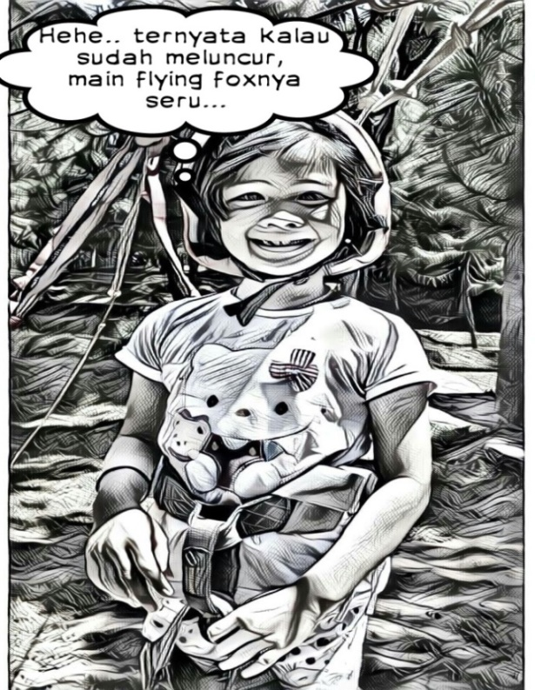

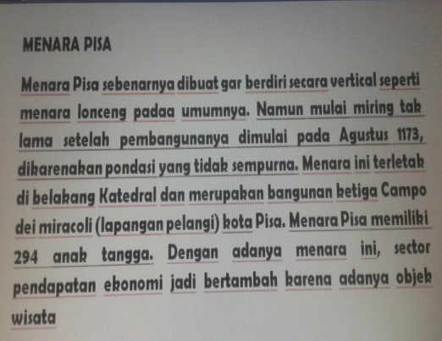

Picture 1
The result of utilizing the application in the form of Flash Card and comic with the theme around the world and fieldtrip
By involving students in the story as a character in a theme, it can make the students motivated and active in following the story delivered by the teacher so it making them enthusiastic and interested in listening, asking, and telling themselves in an event or place. This can be seen from the observations on the activities of students who are active during the learning process takes place. Students are no longer just listening to stories, but they can also tell about the image results from Art Filter Photo Editor & Selfie Camera and Pictsay Pro application.
In the past the students had a tendency to not last long when listening to a story, they would joke with friends or do other activities. Other than that, using media in writing stories involving the students as the main subject, the teacher have the idea to develop the ability to write another story with different situations and different places without losing the elements of good character. Not only that, when students become characters in the story children will feel confident, feel recognized and appreciated, so the process of delivering the story will be meaningful for children.
Based on the activities that have been presented, teachers can be said has been successful in improving their skill in in writing children's story by using a smartphone application. This is means that this Art Filter Photo Editor & Selfie Camera and Pictsay Pro application able to help the teachers in pouring the ideas they have so they can write stories for children. Besides, these measures also increase the interest and motivation of students in following the learning process at school.
Based on the result of analysis and field observation, researchers assumed that by developing the media of Art Filter Photo Editor & Selfie Camera and Picsay Pro application which is based on the learning process principles of PAUD, which are holistic, contextual, meaningful and fun. The holistic principle refers to the stage of children development, which according to Piaget is in a concrete pre-operational period. At this time, the children see the world as a whole. Learning for children at this age is done with a contextual, complete, concrete, and meaningful approach through a series of experiences. Development activities are not done artificially, in some development activities are done separately.
Media development of Art Filter Photo Editor & Selfie Camera and Pictsay Pro application is done by applying thematic approach. This is not a new thing for PAUD teachers. But with the self-made product by the teacher and involving the students as subjects in a story can create a different impression. The emphasis contained in this product is based on an effort to cultivate the character of the student with the theme / subtheme selection, and then begin to establish the purpose of developing the media.
By creating a product from Art Filter Photo Editor & Selfie Camera and Pictsay Pro, teachers get benefit in the learning process that is they can improve their skills in story writing. Due to the application, teachers can get an idea that makes it possible to do photo editing, sketching cartoons and pencil, as well as pop art with a stunning pop art filter. Meanwhile, Pro PictSay application is useful for adding text or narration to the photographs of children as subjects of the story. In order to use this application there is no different from most other editing photo application like Prisma, etc.

PAUD teachers can insert a picture that is already available in an album or take a picture of the students directly. Furthermore, the teacher can select various options such as color settings, put stickers on the image or add other photos on the image. Moreover, teachers also can add text in the selected image. The second formulation is based on the students themselves, who are the subject of the story, and then this may increase the interest and motivation of students to participate in learning activities. Other than that, children will feel that they are directly involved in the story so they can tell about themselves according to the content of the photo. However, this is surely done based on the theme selection and considering the interests and needs of the students. The selection of activities is done through dialogue and exploration of the child's experience related to the chosen sub theme so that the material and development activities become familiar to the children.

In choosing a theme or using a photo as an educational medium, the teacher should pay attention to several things. According to Rinanto (1982: 34), there are four conditions that need to be considered in making the photo as an educational medium that is: (1) the image must be authentic, (2) the image must be simple, (3) the picture must carry the message, (4) the image must be dynamic .

- CONCLUSION
Based on the results of the research the development of teacher’s skills in writing children's story, it can be concluded that writing a story by using the media of Art Filter Photo Editor & Selfie Camera and Pictsay Pro that are:
- Improving teachers' skills in writing the story, because the existence of these products gives the idea to develop a story with regard to the principles in PAUD development, which are holistic, contextual, meaningful and fun.
- Student activeness in story learning also increased, this is because children can be the subject of the story so they feel enthusiastic and has a high interest to listening, asking and telling themselves in an event or somewhere according to the theme of the learning process.
- Increase children's confidence and create the feelings of acceptance and acknowledgment also appreciation.

BIBLIOGRAPHY
Fajri. 2005. Kamus Besar Bahasa Indonesia. Difa Publiser: Jakarta

Hernowo. 2003. Quantum Writing. Jogjakarta: MLC

Nurmina, Menulis Kreatif Cerita Fiksi Anak. Jupendas, Vol. 1, No. 2, September 2014 | Issn: 2355-3650

Richey & Klein, 2007. Design and development research, methods, strategies, and issues. London: Lawrence Erlbaum Associates, Publishers

Stefanus rodrick juraman, Pemanfaatan Smartphone Android Oleh Mahasiswa Ilmu Komunikasi Dalam Mengakses Informasi Edukatif. Journal Volume III. No.1. Tahun 2014

Sugiyono. (2009). Metode penelitian kuantitatif kualitatif dan R & D. Bandung: Penerbit Alfabeta

Widuroyekti, B. 2014. Model Pengembangan Kemampuan Pra-Membaca-Menulis Berbasis.Program Studi PGSD, FKIP Universitas Terbuka

