FLIPPED CLASSROOM MODEL THROUGH MULTIMEDIA TECHNOLOGY AND STUDENT PERFORMANCE IN DIRECTED NUMBERS

Article Info |  | ABSTRACT
Article history:  Received Jun 12, 201x  Revised Aug 20, 201x  Accepted Aug 26, 201x |  | The recent globalisation and the emergency of COVID-19 require a teaching and learning environment that encourages the use of technology. This action research study investigated the effectiveness of a flipped classroom model through multimedia technology in improving student performance in directed numbers, given the difficulty and misconceptions of students in this mathematical concept. A total of 30 Year 9 students conveniently sampled from one of the secondary schools in Brunei Darussalam served as participants in this study. The action taken involved a pretest, intervention, posttest and interviews. The results of the paired sample t-test revealed that student performance in the posttest (mean = 6.57, SD =1.31) was significantly higher than in the pretest (mean = 5.67, SD=1.90) with t(29)=2.18, p=0.037<0.05. This indicates that performance in directed numbers significantly improved after the flipped classroom intervention. Although the students made some misconceptions and common errors after the intervention, approximately 40% of their performance was explained by the provided intervention. The thematic analysis results revealed that the students had positive perceptions of the flipped classroom model as it encouraged their readiness, participation, and motivation. Challenges such as nervousness in group work and time constraints were reported. Generally, students preferred a flipped classroom and traditional face-to-face instruction in learning directed numbers.
Keywords:
Academic performance
Brunei Darussalam
Directed numbers
Flipped classroom model
Multimedia technology

Copyright © 2019 IKIP Siliwangi.
All rights reserved.
Corresponding Author:

How to Cite:
Last name-1, Initial First and Middle name-1., Last name-2, Initial First and Middle name-2., & Last name-3, Initial First and Middle name-3. (2019). Title Title Title Title. Infinity, X(X), XX-XX.

- INTRODUCTION
Education in the 21st century has witnessed several changes. Approaches that encourage more student-centred compared to teacher-centred instruction continue to be developed and integrated into teaching and learning. Globalisation, the development of technology, and the emergency of COVID-19 have shown that traditional approaches to teaching and learning may not meet current educational needs and goals (Jamil et al., 2021; Shahrill et al., 2021a, 2021b). This has called for a need to constantly create instructional environment that encourages the use of technology (Bishop & Verleger, 2013). In responding to the changing needs of education, one of the approaches that have attracted recent research attention is the flipped classroom model. Baker (2000) introduced this approach to instruction as a component of blended and inquiry-based instruction. It is an approach in which homework and classroom activities are interchanged (Ash, 2012), such that students study instructional materials at home with their peers and teachers, followed by the teacher giving feedback and engaging in directed conversations during class time (Lin & Chen, 2016; Say & Yildirim, 2020). It exposes the students to study and understand instructional materials out-of-classroom, and in the classroom, do activities that support learning with the help of the teacher (Moravec et al., 2010). Students mainly study and master instructional materials through multimedia technology by watching videos, listening to podcasts, and reading e-books (Dominic-Ugwu & Nonyelum, 2019; Balu, 2020).
Using a flipped classroom model is associated with high student performance, motivation and retention (Sirakaya & Ozdemir, 2018; Say & Yildirim, 2020; Busebaia & John, 2021), and this is irrespective of subject areas and educational level (Strelan et al., 2020). It promotes student-centred learning, leading to student engagement, active participation, and self-directed learning (Pierce & Fox, 2012; Qader & Yalcin Arslan, 2019). Students can learn instructional materials at their own pace, ensures effective use of classroom time because most of the instructional tasks are done by the students at home, and the classroom time is used to clarify student misconceptions (Fulton, 2012; Matzin et al., 2017; Hew & Low, 2018). Given that a flipped classroom model encourages collaboration among their peers, high-ability students can assist low-ability students in constructing their knowledge on a given topic (Ferreri & O’Connor, 2013; Nielson et al., 2018). Using a flipped classroom model encourages students to think creatively within and outside the classroom (Herreid & Schiller, 2013).
However, the approach to teaching and learning has some disadvantages. Teachers are unable to know if students learned instructional concepts at home. The lack of internet and other devices such as mobile phones, tablets and computers that make learning possible are other notable challenges (Jenkins, 2012). Other demerits of the flipped model include the high cost that comes with technology and the failure to create an environment where students can ask questions when learning at home (Jenkins, 2012). Despite these demerits, a flipped classroom model inverts the traditional model of instruction. It has the possibility of increasing student readiness as the learning content is introduced to students before the physical class. This allows teachers more instructional time to guide students through practical, active, and innovative ways of learning.
Previous studies have emphasised the need to use multimedia technologies in flipped classrooms and provide the technical support needed for such multimedia (Oliveira, 2018). Integrating multimedia in flipped learning has gained considerable relevance in teaching and learning. Therefore, previous research attempts have focused on technological and conceptual improvement in using a flipped classroom model, especially on monitoring student learning while they are at home (Jovanovic et al., 2017). A flipped classroom model does not necessarily need to be implemented in an online platform, as it can also be done using multimedia technologies where text, visuals, animation, video, and sound can be merged to improve teaching and learning (Abdurasulovich et al., 2020). Since multimedia triggers multiple senses of audiences at a time, using various media in a flipped classroom model can produce conclusive results in teaching and learning (Yohannes et al., 2016; Rajendra & Sudana, 2018). Using multimedia in a flipped classroom serves as a varied source of information for students, making learning content accessible to students based on their preferences (Aprianto et al., 2020; Cevikbas & Kaiser, 2020).
How multimedia is used in a flipped classroom model to meet student needs and how students handle multimedia resources are also essential to determine the success of the flipped classroom methodology. Oliveira (2018), for example, indicated that flipping the classroom is not a sufficient condition for improvement in student learning and engagement. However, how instructional resources in different formats reach the students and how well students are able to understand such resources are relevant. Although student perceptions about flipped learning model are generally positive, students who have positive perceptions are those who can access instructional materials on time and without difficulty. At the same time, they prefer traditional teaching methods that are more interactive and learner-centred compared to a flipped classroom model (Yohannes et al., 2016; Oliveira, 2018).
To this end, this study investigates the effectiveness of using multimedia technology in a flipped classroom model in improving student performance in directed numbers. Directed numbers or integers have both direction and size, with one direction being positive and the other negative. For example, in $4-(-3)$, both 4 and ($-$3) are directed numbers with the 4 and ($-$3) being positive and negative, respectively. Having a sufficient understanding of these numbers are applicable in everyday life (Fuadiah et al., 2017). They are helpful in reading temperature. A temperature of ($-$10) degrees means that it is 10 degrees away from and less than 0, suggesting a high level of coldness compared to a temperature reading of 10 degrees.
Understanding directed numbers are also helpful in profit and loss. It helps to know how less or more can be done to achieve satisfactory results in all aspects of life. Profit is denoted by positive numbers in business transactions, while negative numbers indicate losses. Understanding directed numbers help to check account balance (Makonye & Fakude, 2016). If money is added to one’s account and there are adequate funds in the account, it is denoted by a positive number. In contrast, money withdrawn from one’s account is represented by a negative number. In the health sector, directed number is also applicable. Normal blood pressure will record a positive number, while blood pressure below normalcy can be negative. This suggests that directed numbers are significant in every life, and the failure of students to have a good understanding of such numbers may cause serious challenges when applying such numbers in their daily activities.
Students have inadequate understanding and several misconceptions, despite the relevance of directed numbers (Vlassis, 2008; Lamb et al., 2012; Boefferding, 2014). Mostly, they are unable to differentiate between a negative sign used as an operation and one used as a symbol (Lamb et al., 2012). This creates difficulties for them when performing operations involving directed numbers. Student difficulty in directed numbers and other mathematical concepts exists in Brunei Darussalam (hereafter referred to as Brunei). Previous research has consistently reported that students have difficulty understanding algebraic expressions, fractions, simultaneous, linear, and quadratic equations (Hamid et al., 2013; Sarwadi & Shahrill, 2014; Shahrill, 2018; Johari & Shahrill, 2020; Rosli et al., 2020). In most studies, the predominant cause of low performance was attributed to factors such as over-reliance on past examination questions, anxiety and stress, and teaching approaches (Zakaria et al., 2013; Salam & Shahrill, 2014; Shahrill, 2018; Abdul Latif, 2021) and inadequate understanding and misconceptions about directed numbers (Levison, 2016). Despite these gaps, interventions to improve student understanding and performance in targeted numbers are scarce.
Therefore, this study that provides a flipped classroom intervention to evaluate its effectiveness in improving student performance in directed numbers is timely. For the studies that focused on secondary schools in Brunei, emphasis was placed on geography (Nawi et al., 2015) and history (Latif et al., 2017). The paucity of studies focused on secondary school mathematics did not consider directed numbers (Manjanai & Shahrill, 2016; Toh et al., 2017). Therefore, more studies are necessary to develop a more in-depth analysis of the effects of the flipped classroom model in the teaching and learning of secondary school mathematics. This present study provides a flipped classroom intervention to assess its efficacy in improving student performance in directed numbers using secondary school students in Brunei. The following research questions were answered:
- How effective is a flipped classroom model through multimedia technology in improving student performance in directed numbers?
- What perceptions do students have about using a flipped classroom model through multimedia technology as an instructional option?

- METHOD
This study adopted the action research approach, as it sought to provide a flipped classroom intervention to address student difficulty in directed numbers (Avison et al., 1999; Mertler, 2013). The action included a pretest, an intervention, and a posttest through multiple approaches involving interviewing students to explore their perceptions of the provided intervention. Figure 1 illustrates the action research framework.

Figure 1. Action research framework

The sample for this study consisted of 30 Year 9 conveniently sampled students. They were from one of the government secondary schools (denoted in Figure 1 as School X) in the Belait District of Brunei (about 100 km from the capital city). The selected school had two Year 9 classes, A and B, with 14 and 16 students in each class, respectively. The students in both classes served as participants for this study. The students were used because directed numbers are taught at that grade level, and for this reason, providing intervention on the concept was feasible. Both classes consisted of students with mixed abilities, and for the intervention, the students in both classes were combined.
There were two instruments used to collect data: tests and a structured interview guide. The tests involved a pretest and a posttest on directed numbers. The former was used to assess the entry behaviour of students before the intervention was provided, while the latter was used to evaluate student performance after the intervention. Both tests consisted of similar questions with the same level of difficulty. They involved four categories of questions that required students to find the magnitude, order, add, subtract, and solve temperature related questions involving directed numbers. There were eight questions in both tests. The duration for each test was 30 minutes. The total score on both tests was eight marks, with one mark for each question. The structured interview guide consisted of six questions that asked participants their perceptions of the intervention provided. A total of six participants availed themselves for the interviews. To improve the content validity of the tests, specific lesson objectives were set for each of the areas in the test. A table of test specifications was developed to ensure that all eight questions evenly covered all the areas of the lessons. The created questions for the survey and interview were given to four mathematics teachers who had more than 12 years of teaching experience. These experts evaluated the measurement quality of the questions. All suggestions from these experts were inculcated before administration.
Ethical clearance was obtained from the Faculty’s Ethics Committee of the university. Permissions were also obtained from school leaders through formal approval letters. Students and parents also completed informed consent forms to indicate their willingness to serve as participants and allow their children to participate in this study, respectively. The information and identities of the students have been kept confidential and anonymous. The pretest was conducted before the main intervention. The test was organised online through a WhatsApp group chat, where the pretest was posted. The students were given 30 minutes to answer all eight questions. They posted all their answers in a word file on the same platform, which we downloaded and scored. Second, the lesson intervention, which involved a flipped classroom teaching and learning of directed numbers, was implemented. Participants received a pre-class video lesson sent to them through the WhatsApp group chat to learn at home. Two YouTube videos on directed numbers created by Math Antics (2014a; 2014b) were edited and used in the intervention. The duration of the videos was 13 minutes. The video lessons covered definitions, positive, negative, addition, subtraction, and representing directed numbers on a number line. All instructions regarding the video lesson were also provided in the group chat.
Students were asked to form groups of three to four members to prepare group presentations based on the indicated areas. They were given a week to learn the video lesson and prepare for the in-class presentations. After that, we had a collaborative and activity-based face-to-face classroom session. Each group of students had a 15-minutes presentation to share what they had learned based on specific areas on directed numbers and were given a manila card to write their presentation answers. After each presentation, there was a question-and-answer section. The first author addressed and clarified all student misconceptions and learning gaps based on their presentations and the lesson task they learned at home. The first author facilitated all presentations. Figure 2 illustrates the scenes of the activity-based in-class session of the flipped classroom intervention.

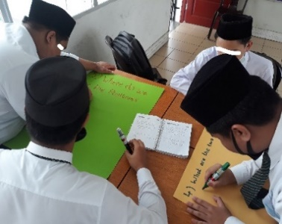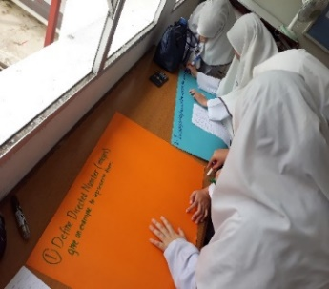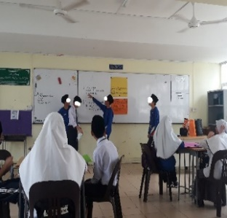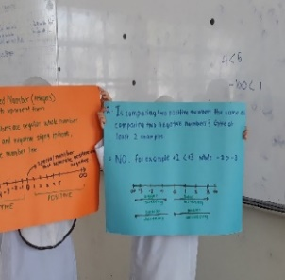
Figure 2. Scenes of the activity-based in-class session of the flipped classroom intervention

The students were actively involved in the activity-based instruction during the in-class intervention (see Figure 2). They satisfactorily prepared their presentations using manila cards and presented their answers to the assigned tasks in front of the whole class. They were able to respond to each of their peers’ questions based on their presentations. The facilitator gave minimal guidance and comments since the students had completed the tasks individually and in groups at home before the in-class presentations and interaction. Finally, after the intervention, the posttest was conducted on the same day, and all 30 students were combined to take the test. There was a tranquil testing environment, and instructions regarding the posttest were given. The posttest lasted for 30 minutes, after which all scripts were collected, marked, and recorded. The pretest and posttest scores were entered into SPSS, which aided the analysis. Data cleaning was performed to address all missing values and outliers. A paired sample t-test was performed to compare the pretest and posttest scores to check and test for a mean difference. This helped to determine the effectiveness of the flipped classroom intervention. The interview data were analysed thematically.

- RESULTS AND DISCUSSION
3.1 Flipped classroom model and student performance in directed numbers
The overall results showing the efficacy of the flipped classroom intervention in improving student performance in directed numbers are presented in Table 1.

Table 1. Paired sampled t-test between pretest and posttest scores
 | Descriptive  Statistics |  |  |  |  | 95% Confidence Interval of Mean Difference
 | Mean | SD | Mean difference | SD | Std. Error | Lower | Upper | t | df | Sig. (2-tailed) | Cohen d
Pretest | 5.67 | 1.90 | 0.80 | 2.01 | 0.366 | 0.051 | 1.550 | 2.18 | 29 | .037 | 0.4
Posttest | 6.57 | 1.31
N = 51, SD = standard deviation; mean difference is significant if sig<.05

The results of the paired sample t-test show that student performance in the posttest (mean = 6.57, SD = 1.31) is significantly higher than in the pretest (mean = 5.67, SD = 1.90) with t(29) = 2.18, p = 0.037<0.05 (See Table 1). This suggests that performance in directed numbers significantly improved after the flipped classroom intervention. From the Cohen’s d value of 0.4, it is observed that approximately 40% of student performance in directed numbers is accounted for by the intervention provided, which signifies a medium effect. Since we are particularly interested in how students improved in answering each of the questions correctly, Figure 3 illustrates the number of participants who answered correctly in both tests.

Figure 3. Number of correct responses of participants
Of the eight questions, the participants improved their correct responses for six questions, from questions 3 to 8 (see Figure 3). The number of participants who improved their pretest scores at the posttest level ranges from 1 to 12, with the most significant change of 12 participants for question 5. Participants did not improve their pretest and posttest scores (27 marks for each) for question 2. For question 1, the pretest score (27 marks) is slightly higher than the posttest score (26 marks). We present specific errors and misconceptions based on the eight questions starting from Figure 4.

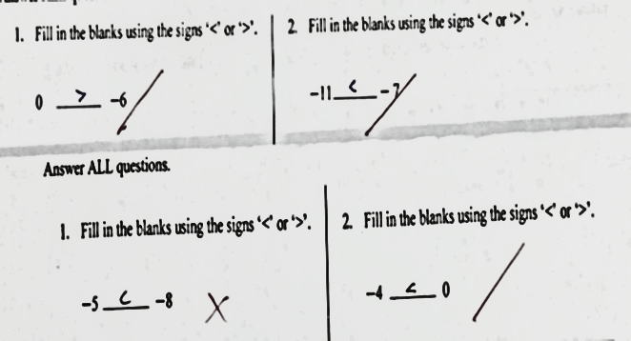
Figure 4. Common errors in questions 1 and 2

In Figure 4, it is observed that participants scored both questions in the pretest but missed one of the questions in the posttest. They make a common error in the posttest by ignoring the negative sign of the negative integers.

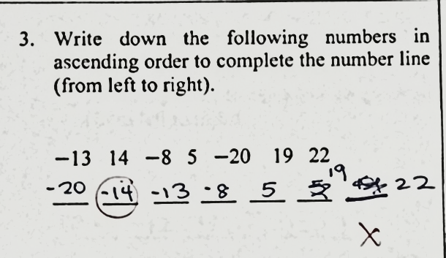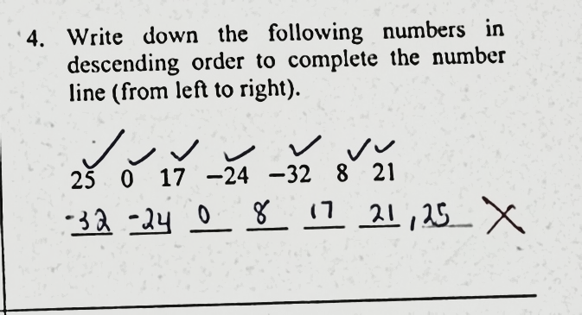
Figure 5. Common errors in questions 3 and 4

In question 3, the participants are confused and read positive integers as negative integers. They ignore the negative sign when arranging the numbers in ascending order and fail to arrange positive numbers first, followed by negative numbers (see Figure 5). In question 4, participants arrange the numbers in ascending rather than descending order. They cannot differentiate the magnitude of positive and negative numbers but mix the numbers up (see Figure 5). According to our observation, they also made the error of misplacing ‘0’ either at the beginning or at the end of the number line. This means that some of them were unable to know the place of zero.

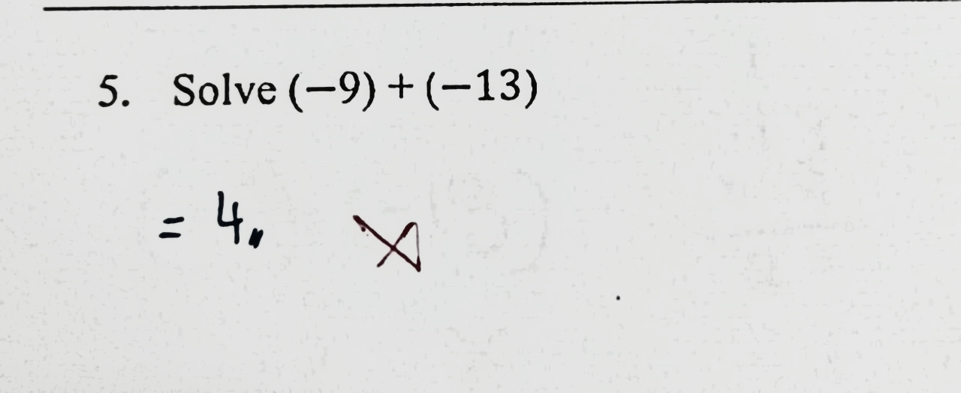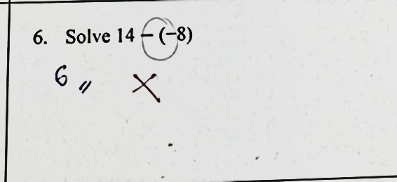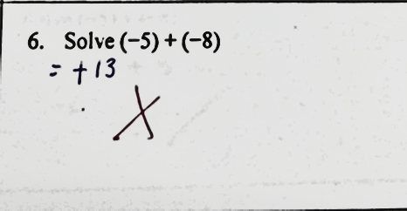
Figure 6. Common errors in questions 5 and 6

The participants ignore the negative sign when performing the operation towards the given integers (see Figure 6). They add two negative integers by disregarding the negative sign after adding. They also fail to differentiate the negative sign as an operation and a symbol. They perform correct calculations of two negative integers but forget to add the negative sign to the final answer (see Figure 6). They still make calculation errors when adding and subtracting directed numbers.
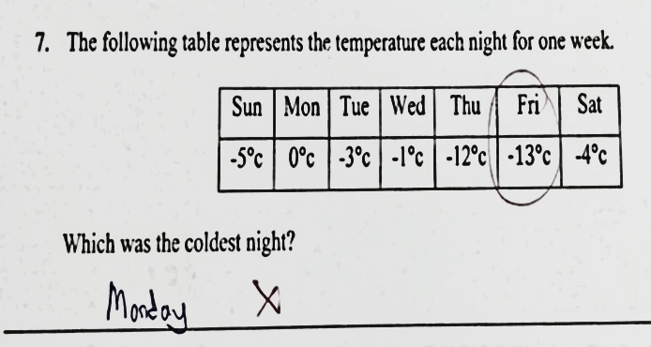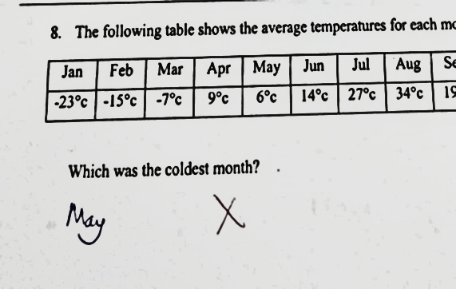
Figure 7. Common errors in questions 7 and 8
The participants think that Monday at 0°C is the coldest night. They have a misconception of assuming that zero is the smallest integer regardless of the negative and positive integers. They similarly answered wrongly by neglecting the negative signs and only focusing on the values. This leads them to choose May with 6°C as the smallest value without considering the negative sign for the negative integers (see Figure 7). This indicates that the participants still had misconceptions despite the significant improvement in performance after the intervention.
3.2 Perceptions of students about the flipped classroom model intervention
Three themes emerged from the interview responses: the usefulness of the flipped class, the preferences of the flipped class to the face-to-face classroom, and the challenges associated with learning from a flipped classroom model. Generally, the participants had positive perceptions about the flipped class model. Despite their positive perceptions, they reported some challenges.
They saw the flipped classroom as helpful in improving their performance in directed numbers as it encouraged collaboration through group work and in-class presentations. This collaboration allowed them to share their knowledge of what they had learned individually and in groups. The pre-class video lesson improved their readiness for the face-to-face class.
S19: I think learning through the video and having a fellow-up physical class is very helpful. I understood what directed numbers are, and how to add and subtract such numbers as well. Engaging in a group work that allowed my peers to share their findings brought up different opinions and thinking among us. In case of any mistakes, my peers were able to correct them, which teaches us the correct way of learning.

S23: I watched the video at home. In the class, we had presentations, questions, and answers. I was able to present in front of my peers, which made me very happy. There was teamwork before arriving at answers. There was knowledge sharing as well. In temperature, I have now understood that a negative number means too much coldness. A positive number is bigger than a negative number, and zero separates all of them…

Furthermore, the participants saw the flipped lesson as helpful and convenient to lean directed numbers. Learning through pre-class video at home improved their understanding. At the same time, the face-to-face classroom helped clarify their misconceptions and received further explanations from their teacher. Generally, they preferred to learn through the pre-class video lessons and face-to-face classes. The latter promoted group work and helped clarify their doubts compared to learning through a pre-class video lesson alone.
S5: It is easy to understand directed numbers when you watch the video at home and have the group work in a physical classroom. I think I will prefer both. But it is always good to learn through the video at home before the actual class.
S1: Can we choose both? Because both are helpful for students. The flipped classroom helps students understand the video and learn by themselves. The traditional classroom helps students to get further explanations from the teacher.
Although participants found the flipped classroom model helpful in enhancing their understanding and performance in directed numbers and expressed positive perceptions of its use, they reported some challenges. Some of them were nervous in presenting their findings to the entire class. They were also faced with limited time for group discussions which affected their preparation for the presentation. Negative attitudes of group members also affected their meeting time.
S20: I did not have much time to discuss with my group, which affected my understanding and contributions.
S29: Um…I was nervous when I presented my answers on directed numbers to the whole class. This made me to be shy. There were also different opinions which sometimes disturbed the class.
  - Discussion
The results of this study indicate that the implementation of a flipped classroom through multimedia technology has the potential to improve student performance in directed numbers. This is expected because students are exposed to instructional tasks at home, preparing them for face-to-face instruction. The teacher facilitates classroom interaction through group work and activity-based learning. This encourages student collaboration, knowledge sharing, and motivation. The teacher also clarifies any misconceptions and misunderstandings that students may have. These are the characteristics of a flipped classroom model reported in the literature (Ash, 2012; Lin & Chen, 2016; Say & Yildirim, 2020), which encourages student-centred learning (Jamaludin & Osman, 2014). Therefore, students are expected to improve their performance.
The results of this study indicating that a flipped classroom model has the potential of improving student performance in directed numbers confirm existing studies that support the efficacy of the flipped model in teaching and learning (Sirakaya & Ozdemir, 2018; Strelan et al., 2020; Busebaia & John, 2021). The use of multimedia and, in particular, video lessons enhance student performance. Video lessons have the potential to improve student engagement and, at the same time, provide explanations and help them remember learning content compared to audio or other multimedia (Hew & Low, 2018). Students have the flexibility to rewind, pause, and skip the video lesson based on their preference, which may positively affect their understanding and performance (Fulton, 2012; Matzin et al., 2017). Given this analysis, this might have helped students enhance their understanding when provided with the pre-class video lesson on directed numbers. This confirms the relevance of multimedia technology such as video lessons in improving student performance in a flipped classroom model (Botha-Ravyse & Reitsma, 2015; Oliveira, 2018), especially in directed numbers. Therefore, it was not surprising that the students reported that they could access instructional content conveniently when given the pre-class video lesson, which confirmed the literature (Aprianto et al., 2020).
It is also interesting to reiterate that students in this present study generally perceived a flipped classroom environment positively. Considering the students’ zeal, participation, motivation, and understanding, their positive views were expected (Bofferding, 2014; Oliveira, 2018). However, students still had some misconceptions and misunderstandings and made several errors in directed numbers. This reminds us of student difficulty on directed numbers reported in the literature (Vlassis, 2008; Lamb et al., 2012; Boefferding, 2014) and the errors students make, especially on negative integers acknowledged by previous studies (Lamb et al., 2012; Levison, 2016; Fuadiah et al., 2017). We also agree with Oliveira (2018) that a flipped class is not a sufficient condition for improvement in student learning. In this study, most students reported being nervous and having limited time to present and discuss. Being nervous in presentations have the likelihood of lowering student self-esteem, which may create common errors in delivering their answers. Therefore, it was not surprising that despite the efficacy of the flipped classroom intervention, students still preferred both flipped and traditional face-to-face learning in directed numbers.

- CONCLUSION
This study examined the effectiveness of a flipped classroom model through multimedia technology in improving student performance in directed numbers. The results showed that a flipped classroom model could improve student performance in directed numbers. Generally, students have positive perceptions of a flipped classroom model. The model encourages student readiness, preparation, participation, and motivation in the teaching and learning process. Using a flipped classroom also comes with challenges. Students can be nervous about presenting their results to their peers and may lack group work and discussion time. Therefore, they prefer flipped classroom lessons and traditional face-to-face teaching and learning of directed numbers. Our results imply that during the COVID-19 pandemic, a flipped classroom through multimedia technology, such as video lessons, can be an effective and alternative way of teaching and learning directed numbers in secondary schools. It can encourage student-centred learning and improve students’ creative ability, which is vital in teaching and learning mathematics. As the model promotes student collaboration and activeness, our results imply that teachers have the role in motivating students who may be nervous, have low self-esteem, or are shy when working with their peers. This study draws the attention of mathematics teachers and schools to consider a flipped classroom model as an alternative way to teach and learn directed numbers and other mathematics concepts. Key stakeholders such as schools and parents may also consider providing the necessary devices, materials, and environment to make a flipped classroom model feasible.
This action research study covered a relatively small sample size to assess the effectiveness of the intervention provided. The effectiveness of our intervention was also confirmed in the teaching and learning of directed numbers. Therefore, generalising our results to other mathematical concepts, subjects, and in different educational contexts should be done with care. Given these limitations, we suggest that future studies consider replicating our study to other school and educational contexts, using a relatively large sample, to arrive at more robust conclusions on the efficacy of a flipped classroom model in improving student performance in directed numbers. Future studies may consider extending the efficacy of a flipped classroom model to other mathematical concepts and subject areas across educational contexts. Comparing other multimedia technologies in a flipped classroom to assess their effectiveness in improving student performance may also be an important focus of research.

ACKNOWLEDGEMENTS
We are grateful to the students, teachers, and school leaders at the research site for their willingness to participate and contribute their time and resources to this study.

REFERENCES
Abdul Latif, S. N. (2021). Standardised testing and students’ wellbeing: A global or local problem? In P. Le Ha, A. Kumpoh, K. Wood, R. Jawawi & Said, H (Eds.), Globalisation, education, and reform in Brunei Darussalam (pp. 197-215), Palgrave Macmillan.
Abdurasulovich, K. J., Yangiboevich, K. M., Anvarovich, A. A., Xolmurodovich, G. A., & Abdurasulovich, K. O. (2020). Opportunities and results to increase the effectiveness of multimedia teaching in higher education. Journal of Critical Reviews, 7(14), 89-93. http://dx.doi.org/10.31838/jcr.07.14.13
Aprianto, E., Purwati, O., & Anam, S. (2020). Multimedia-assisted learning in a flipped classroom: A case study of autonomous learning on EFL university students. International Journal of Emerging Technologies in Learning, 15(24), 114-127. https://doi.org/10.3991/ijet.v15i24.14017%0d
Ash, K. (2012). Educators view “flipped” model with a more critical eye. Education Week, 32(2), S6-S7.
Avison, D. E., Lau, F., Myers, M. D., & Nielsen, P. A. (1999). Action research. Communications of the ACM, 42(1), 94-97. https://doi.org/10.1145/291469.291479
Balu, A. (2020). Contribution of multimedia technology in education. International Journal of Multidisciplinary Educational Research, 9(2), 127-131. Available at http://s3-ap-southeast-1.amazonaws.com/ijmer/pdf/volume9/volume9-issue10(1)-2020.pdf
Bishop, J. L., & Verleger, M. A. (2013). The flipped classroom: A survey of the research [Paper presentation]. 120th ASEE Annual Conference & Exposition, Atlanta, GA, United States. Available at https://peer.asee.org/the-flipped-classroom-a-survey-of-the-research
Bofferding, L. (2014). Negative integer understanding: Characterising first graders mental models. Journal for Research in Mathematics Education, 45(2), 194-245. https://dx.doi.org/10.5951/jresematheduc.45.2.0194
Botha-Ravyse, C., & Reitsma, G. (2015). Multi-media for flipped classrooms: Engaged nutrition learning in a multi-media enhanced flipped classroom. UNISA Progressio, 37(1), 19-32. https://doi.org/10.25159/0256-8853/570
Busebaia, T. J. A., & John, B. (2020). Can flipped classroom enhance class engagement and academic performance among undergraduate pediatric nursing students? A mixed-methods study. Research and Practice in Technology Enhanced Learning, 15(1), 1-16. https://doi.org/10.1186/s41039-020-0124-1
Cevikbas, M., & Kaiser, G. (2020). Flipped classroom as a reform-oriented approach to teaching mathematics. ZDM- Mathematics Education, 52, 1291-1305. https://doi.org/10.1007/s11858-020-01191-5
Dominic-Ugwu, B., & Nonyelum, O. F. (2019). The assessment of multimedia technology in the teaching of mathematics in secondary schools in Abuja-Nigeria. I. J. Modern Education and Computer Science, 6, 8-18. https://dx.doi.org/10.5815/ijmecs.2019.06.02
Ferreri, S. P. & O’Connor, S. K. (2013). Redesign of a large lecture course into a small-group learning course. American Journal of Pharmaceutical Education, 77(1), 1-9. https://doi.org/10.5688/ajpe77113
Fuadiah, N. F., Suryadi, D., & Turmudi, T. (2017). Some difficulties in understanding negative numbers faced by students: A qualitative study applied at secondary schools in Indonesia. International Education Studies, 10(1), 24-38. https://dx.doi.org/10.5539/ies.v10n1p24
Fulton, K. (2012). The flipped classroom: Transforming education at Byron High School: A Minnesota high school with severe budget constraints enlisted YouTube in its successful effort to boost math competency scores. THE Journal: Technological Horizons in Education, 39 (3), 18-19.
Hamid, M. H. S., Shahrill, M., Rohani M., Mahalle, S., & Mundia, L. (2013). Barriers to mathematics achievement in Brunei secondary school students: insights into the roles of mathematics anxiety, self-esteem, proactive coping, and test stress. International Education Studies 6(11), 1-14. https://doi.org/10.5539/ies.v6n11p1
Herreid, C. F., & Schiller, N. A. (2013). Case studies and the flipped classroom. Journal of College Science Teaching, 42(5), 62-66. Available at https://www.jstor.org/stable/43631584?seq=1#metadata_info_tab_contents
Hew, K. F., & Lo, C. K. (2018). Flipped classroom improves students learning in health professions education: A meta-analysis. BMC Medical Education, 18(38), 1-12. https://doi.org/10.1186/s12909-018-1144-z
Jamaludin, R., & Osman, M. (2014). The use of a flipped classroom to enhance engagement and promote active learning. Journal of Education and Practice, 5(2), 124-131. https://iiste.org/Journals/index.php/JEP/article/view/10648
Jamil H., Ramli H. M., & Leong E. (2021). Advocating blended learning for university undergraduate level mathematical instruction beyond Covid-19. In S. A. Abdul Karim, & S. A. Husain (Eds.), Engineering and sciences teaching and learning activities. Studies in systems, decision and control (pp. 33-45). Springer, Cham. https://doi.org/10.1007/978-3-030-79614-3_4
Jenkins, C. (2012). The advantages and disadvantages of the flipped classroom. Retrieved from: http://info.lecturetools.com/blog/bid/59158/The-Advantages-and-Disadvantages-of-the-Flipped-Classroom
Johari, P. M. A. R. P., & Shahrill, M. (2020). The common errors in the learning of the simultaneous equations. Infinity Journal, 9(2), 263-274. https://doi.org/10.22460/infinity.v9i2.p263-274
Jovanović, J., Gašević, D., Dawson, S., Pardo, A., & Mirriahi, N. (2017). Learning analytics to unveil learning strategies in a flipped classroom. The Internet and Higher Education 33(4), 74-85. http://dx.doi.org/https://doi.org/10.1016/j.iheduc.2017.02.001
Lamb, L. L., Bishop, J., Philipp, R., Schappelle, B. P., Whitacre, I., & Lewis, M. (2012). Developing symbol sense for the minus sign. Mathematics Teaching in the Middle School, 18(1), 5-9. https://doi.org/10.5951/mathteacmiddscho.18.1.0005
Latif, A. S. W., Matzin, R., Jawawi, R., Mahadi, M. A., Jaidin, J. H., Mundia, L., & Shahrill, M. (2017). Implementing the flipped classroom model in the teaching of history. Journal of Education and Learning (EduLearn), 11(4), 374-381. https://doi.org/10.11591/edulearn.v11i4.6390
Levison, M. (2016). Challenges faced by Z.J.C. pupils in the learning of directed numbers: A case study. Unpublished dissertation, Bindura University of Science Education, Zimbabwe. Available at https://elibrary.buse.ac.zw/bitstream/123456789/5535/1/Levison%20eDU..pdf
Lin, P. C., & Chen, H. M. (2016). The effects of flipped classroom on learning effectiveness: Using learning satisfaction as the mediator. World Transactions on Engineering and Technology Education, 14(2), 231-244. Available at http://www.wiete.com.au/journals/WTE&TE/Pages/Vol.14,%20No.2%20(2016)/01-Lin-PC.pdf
Makonye, J. P., & Fakude, J. (2016). A study of errors and misconceptions in the learning of addition and subtraction of directed numbers in grade 8. SAGE Open, 6(4), 215824401667137. https://dx.doi.org/10.1177/2158244016671375
Manjanai, S. N. N. P., & Shahrill, M. (2016). Introducing the flipped classroom strategy in the learning of year nine factorization. The International Journal of Interdisciplinary Educational Studies, 11(4), 35-56. https://dx.doi.org/10.18848/2327-011X/CGP
Math Antics (2014a). Math antics – negative numbers. Available at https://www.youtube.com/watch?v=OAoLCXpao6s
Math Antics (2014b). Math antics – adding and subtracting integers. Available at https://www.youtube.com/watch?v=_BgblvF90UE
Matzin, R., Shahrill, M., Mahalle, S., Hamid, M. H. S., & Mundia, L. (2013). A comparison of learning styles and study strategies scores of Brunei secondary school students by test anxiety, success attributions, and failure attributions: Implications for teaching at-risk and vulnerable students. Review of European Studies, 5(5), 119-127. http://dx.doi.org/10.5539/res.v5n5p119
Mertler, C. A. (2013). Classroom-based action research: Revisiting the process as customisable and meaningful professional development for educators. Journal of Pedagogic Development, 3(3), 38-42. https://uobrep.openrepository.com/handle/10547/335968
Moravec, M., Williams, A., Aguilar-Roca, N., & O'Dowd, D. K. (2010). Learn before lecture: A strategy that improves learning outcomes in a large introductory biology class. CBE-Life Sciences Education, 9(4), 473-481. https://doi.org/10.1187/cbe.10-04-0063
Nawi, N., Jawawi, R., Matzin, R., Jaidin, J. H., Shahrill, M., & Mundia, L. (2015). To flip or not to flip: The challenges and benefits of using flipped classroom in geography lessons in Brunei Darussalam. Review of European Studies, 7(12), 133-44. http://dx.doi.org/10.5539/res.v7n12p133
Nielson, P. L., Bean, N. W., & Larsen, R. A. A. (2018). The impact of a flipped classroom model of learning on a large undergraduate statistics class. Statistics Education Research Journal, 17(1), 121-140, http://www.stat.auckland.ac.nz/serj
Oliveira, L. (2018). Flipping the classroom with multimedia resources to regulate learning pace: A case study. ACM International Conference Proceeding Series, 708-715. https://doi.org/10.1145/3284179.328431
Pierce, R., & Fox, J. (2012). Vodcasts and active-learning exercises in a “flipped classroom” model of a renal pharmacotherapy module. American Journal of Pharmaceutical Education, 76(10), 1-5. https://doi.org/10.5688/ajpe7610196
Qader, R. O., & Yalcin, A. F. (2019). The effects of flipped classroom instruction in writing: A case study with Iraqi EFL learners. Teaching English with Technology, 19(1), 36-55. Available at https://files.eric.ed.gov/fulltext/EJ1204642.pdf
Rajendra, M., & Sudana, M. (2018). The influence of interactive multimedia technology to enhance achievement students on practice skills in mechanical technology. Journal of Physics: Conference Series, 953, 1-5. https://dx.doi.org/10.1088/1742-6596/953/1/012104
Rosli, S., Shahrill, M., & Yusof, J. (2020). Applying the hybrid strategy in solving mathematical word problems at the elementary school level. Journal of Technology and Science Education 10(2), 216-230. https://doi.org/10.3926/jotse.965
Salam, N. H. A., & Shahrill, M. (2014). Examining classroom interactions in secondary mathematics classrooms in Brunei Darussalam. Asian Social Science 10(11), 92-103. https://doi.org/10.5539/ass.v10n11p92
Sarwadi, H. R. H., & Shahrill, M. (2014). Understanding students’ mathematical errors and misconceptions: The case of year 11 repeating students. Mathematics Education Trends and Research, 2014, 1-10. https://doi.org/10.5899/2014/metr-00051
Say, F. S., & Yıldırım, F.S (2020). Flipped classroom implementation in science teaching. International Online Journal of Education and Teaching (IOJET), 7(2), 606-620. http://iojet.org/index.php/IOJET/article/view/759
Shahrill, M. (2018). Teachers’ devotion to review lessons: insights to the mathematics lessons in Brunei Darussalam. Journal of Physics: Conference Series 1028(1), 012158. https://doi.org/10.1088/1742-6596/1028/1/012158
Shahrill, M., Noorashid, N., & Keasberry, C. (2021b). COVID-19: Educational practices and responses in Brunei Darussalam. In L. H. Phan, A. Kumpoh, K. Wood, R. Jawawi & H. Said (Eds.), Globalisation, education, and reform in Brunei Darussalam (pp. 325-354). Palgrave Macmillan. https://doi.org/10.1007/978-3-030-77119-5_16
Shahrill, M., Petra, M. I., Naing, L., Yacob, J., Santos, J. H., & Abdul Aziz, A. B. Z. (2021a). New norms and opportunities from the COVID-19 pandemic crisis in a higher education setting: Perspectives from Universiti Brunei Darussalam. International Journal of Educational Management, 35(3), 700-712. https://doi.org/10.1108/IJEM-07-2020-0347
Sirakaya, A. D., & Ozdemir, S. (2018). The effect of a flipped classroom model on academic achievement, self-directed learning readiness, motivation and retention. Malaysian Online Journal of Educational Technology, 6(1), 76-91. Available at https://files.eric.ed.gov/fulltext/EJ1165484.pdf
Strelan, P., Osborn, A., & Palmer, E. (2020). The flipped classroom: A meta-analysis of effects on student performance across disciplines and education levels. Educational Research Review, 30, 100314, 1-22. https://doi.org/10.1016/j.edurev.2020.100314
Toh, T. S., Tengah, K. A., Shahrill, M., Tan, A., & Leong, E. (2017). The flipped classroom strategy: The effects of implementation at the elementary school level mathematics lessons. In S. De Silva (Ed.), Proceedings of the 3rd International Conference on Education (Vol. 3, pp. 186-197). The International Institute of Knowledge Management. https://doi.org/10.17501/icedu.2017.3120
Vlassis, J. (2008). The role of mathematical symbols in the development of number conceptualisation: The case of the minus sign. Philosophical Psychology, 21(4), 555-570. https://doi.org/10.1080/09515080802285552
Yohannes, H. M. G., Bhatti, A. H., & Hasan, R. (2016). Impact of multimedia in teaching mathematics. International Journal of Mathematics Trends and Technology (IJMTT), 39(1), 80-83. Available at https://www.ijmttjournal.org/archive/ijmtt-v39p510
Zakaria, E., Solfitri, T., Daud, Y., & Abidin, Z. Z. (2013). Effect of cooperative learning on secondary school students’ mathematics achievement. Creative Education 4(2), 98–100. https://doi.org/10.4236/ce.2013.42014

