DEVELOPMENT OF MAZE CASE GAMES BASED ON WORD WALLS THE THEME OF MY HEROES IN IMPROVING ELEMENTARY SCHOOL STUDENTS' CRITICAL THINKING ABILITY

Yuli Mulyawati¹, Yuyun Elizabeth²
¹Universitas Pakuan, Indonesia
²Universitas Pakuan, Indonesia
¹yuli_mulyawati@unpak.ac.id, ²yuyunpatras64@gmail.com

Abstract
The role of schools and teaching staff play an important role in the era of society 5.0. especially during a pandemic, learning activities take place through online media using various supporting applications, such as zoom, google classroom, google class Meetings, and others. The use of this application media requires more insight from educators. However, in reality, currently, not all educators have sufficient information technology so learning carried out online looks monotonous and difficult for students to understand. Learning focuses more on face-to-face with zoom, the teaching materials displayed are only in the form of words or power points, the teacher's explanations are more verbal, not using applications or interactive learning media so that the reasoning and creative power of students is not well explored. The problem was recognized and based on the narrative of several teachers at SDN Panaragan 1, Bogor City when the researchers made initial observations at the school regarding the problems that existed in elementary schools. Efforts that can be made to overcome monotonous learning are interactive educational games, namely word wall-based maze games. The aim is to see an overview of the Improvement and Effectiveness of the Wordwall-Based Maze Chase Game Development in improving the critical thinking and reasoning abilities of Elementary School students/ The method used is Research and Development, namely development in learning media. The learning media development model used is analysis, design, development, implementation, and evaluation. Based on research data , maze chase is an appropriate educational game to be used as a learning medium. Based on data processing results, 93.3% of students stated that the educational games given by the teacher challenged them to fill it properly. Moreover, games are made in the form of labyrinths that challenge students to think critically and reason. Whereas 6.7% of students or a small portion stated that educational games were not challenging for them to fill properly.
Keywords: Maze Chase, Games, Elementary School

INTRODUCTION
The role of schools and teaching staff play an important role in the era of society 5.0. especially during a pandemic, learning activities take place through online media using various supporting applications, such as zoom, google classroom, google class Meetings, and others. The use of this application media requires more insight from educators. However, in reality, currently, not all educators have sufficient information technology so learning carried out online looks monotonous and difficult for students to understand. Learning focuses more on face-to-face with zoom, the teaching materials displayed are only in the form of words or power points, the teacher's explanations are more verbal, not using applications or interactive learning media so that the reasoning and creative power of students is not well explored. The problem was recognized and based on the narrative of several teachers at SDN Panaragan 1, Bogor City, when the researchers made initial observations at the school regarding the problems that existed in elementary schools. Efforts that can be made to overcome monotonous learning are interactive educational games, namely word wall-based maze games. The aim is to see an overview of the Improvement and Effectiveness of the Wordwall-Based Maze Chasee Game Development in improving the critical thinking and reasoning abilities of Elementary School students/ The method used is Research and Development, namely development in learning media. The learning media development model used is analysis, design, development, implementation, and evaluation..

METHOD
This type of research is research and development (research and development). Development research is a research technique used to produce a particular product and to test its effectiveness of that product. This development research is used to produce cutting-edge products (Sugiyono, 2016) The product being developed is the development of teaching aids on output system material using the ADDIE model through 5 stages, namely analysis, design, development, implementation, and evaluation. The learning pillars developed refer to the application of a scientific approach or a scientific approach, according to the 2013 Curriculum. The Game Maze Case development model used is the ADDIE model with a limited deployment stage. The complete ADDIE model development steps are as follows:
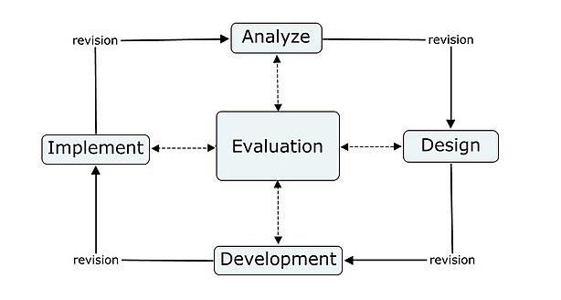

Gambar 4. Tahapan desain ADDIE (Benny, 2010)
Figure 2. ADDIE Development Model Stages
Research Respondents
The trial was carried out after validating three (3) expert teams namely media experts, design experts, and computing experts. While the field trials were conducted on 8 elementary school students who were taken from grade 4 students at SDN Panaragan 1 Bogor City.

Research Procedure
The procedure for this study is in accordance with Figure 3 below.

Figure 3. Product Revision Activity Steps (software)

Data collection technique
Data collection techniques using instruments in the form of questionnaires and interviews. This questionnaire is intended for expert validation assessment and student responses. While the interview instrument is used to strengthen the data obtained from the questionnaire instrument. The interview instrument was used in the expert validation test.

RESULTS AND DISCUSSION
Results
The research was conducted in January 2023 in the even semester in class 4 at SDN Panaragan 1 Bogor city. The research was carried out using the ADDIE method.
- Analyzes
The analysis is carried out by examining the need for interactive learning media which is currently very much needed in classroom learning so that students are more motivated, and can think critically, and have high reasoning power. Needs analysis is based on the results of interviews with teachers who convey that learning media are made mostly in the form of teaching materials while media in the form of games are rarely made by teachers. Based on this, the researchers decided to make an educational game with a word wall platform, namely a maze chase entitled "The Struggle of the Heroes". Therefore the game maze chase was given the same name.
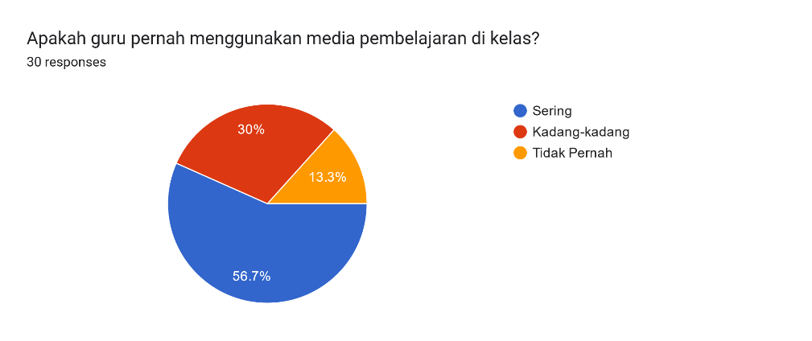
Based on these data, 56.7% of students stated that the teacher had used instructional media in class. Meanwhile, 30% of students stated that sometimes and 13.3% said that the teacher never used learning media in class.
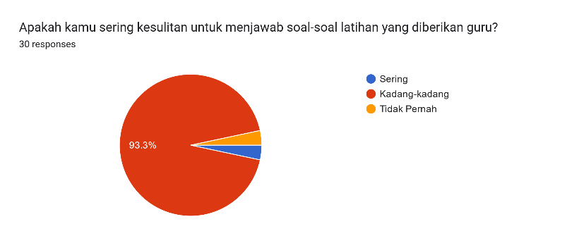
Based on the data above, 93.3% of students had difficulty answering the practice questions given by the teacher, because the questions given were HOTS-based and required students to think critically. Meanwhile, 7.7% of students stated that the questions were sometimes difficult and sometimes easy.
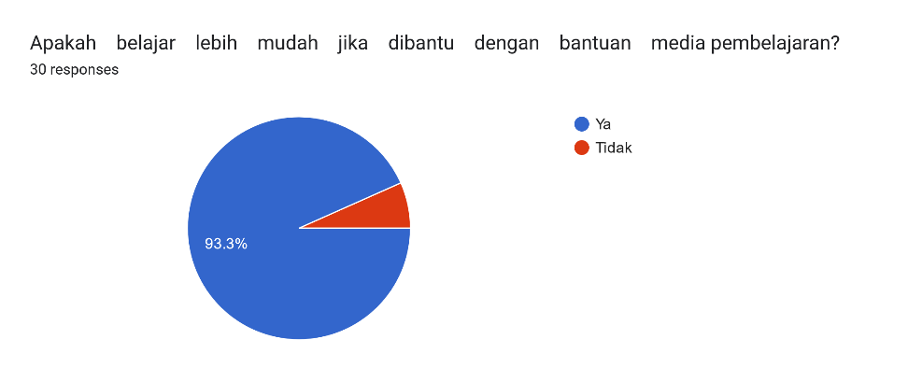
Based on the data above, 93.3% of students stated that learning would be easier if assisted by learning media.
Based on the results of interviews, questionnaires, and documentation studies, the researchers are interested in making word wall-based maze chase educational games. These games combine games with existing material content in lessons so that students become more challenged to answer questions in these games with games in the form of a maze that require ingenuity and thoroughness in avoiding obstacles to get the correct answer.

- Design
Making a game required steps in its manufacture. The steps are as follows:
- Prepare online game media, Maze Chase.
- Go to the https://wordwall.net page. Several template options will appear.
- Select the Maze Chaze game template, the title of the game material will appear.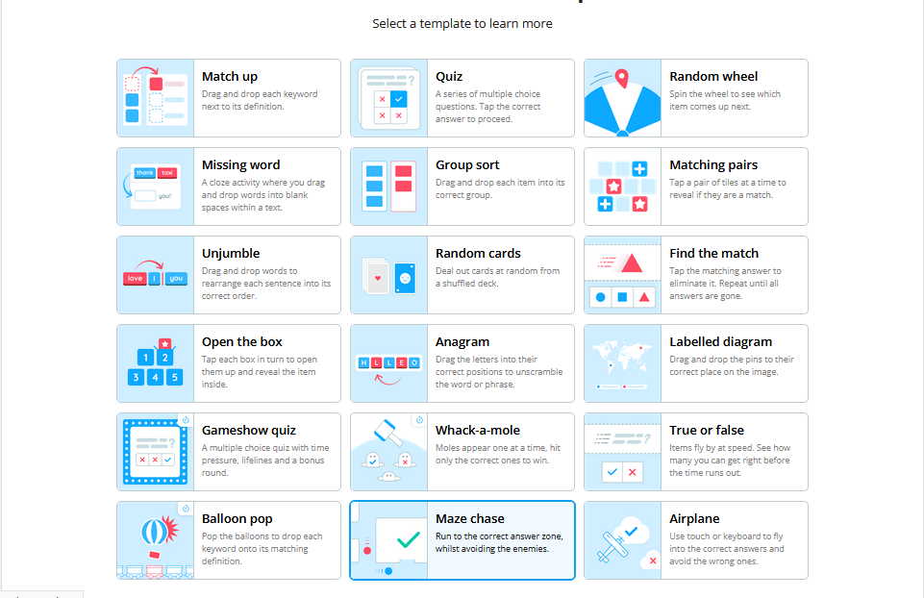
- The author gives the title of the Games "The Struggle of the Heroes".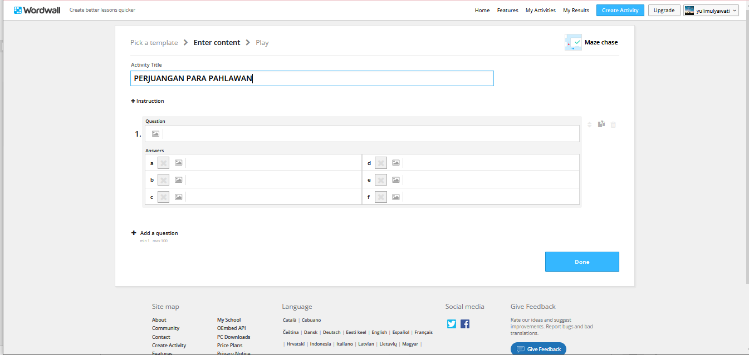
- Enter the text that will be made about the game.
- The number of questions will determine the number of levels. If there are twenty-five questions, students must play them up to level twenty-five.
- When finished writing questions, select the menu done. Then the Maze Chase game will appear which already contains the questions made earlier.
- Then the user plays the game first.
- Users can set the timer, speed, level, scoring, and the correct answer key.
- After all the settings are done, click the share button.
- A choice will appear with whom to share, so choose my student and set it as a task.
- Then copy the link, then share it on social media such as WhatsApp, Twitter, Facebook, Instagram, and others
- Game Maze Chase is ready to be played by students.
- Students who have obtained the link can directly access it by writing the student's name, then playing it.
- How to play it is easy. Students are faced with the challenge of questions whose answers are on a map.
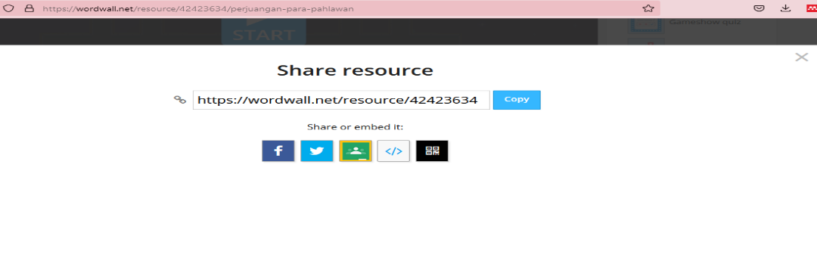
- Students must avoid the pursuit of the enemy, then run
- Students must avoid the enemy's pursuit, then run toward the correct answer. If successful will go to the next level. If it doesn't work or the answer is wrong, you can't proceed to the next level.
- After the game ends, students and teachers can see the results of the scoring and ranking. Learning the Theme of the Struggle of Heroes by using the Maze Chase game is quite effective in increasing students' critical thinking in learning.
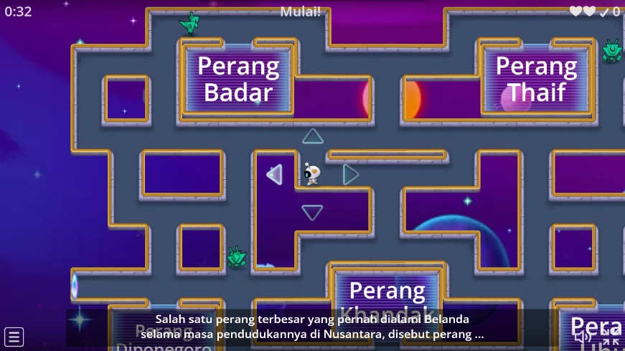

- Development
To be able to test the validity level of a game to be suitable for use in this study, expert judgment was carried out by fellow lecturers in the Learning Media course, namely Resyi A Gani, M.Pd.. and Dendy Saeful Zen, M.Pd.. based on media experts who made it feasible to use.
- Implementation
Maze chase games are given to students in closing learning activities. Based on the results of interviews with students that with these maze games, they feel learning is more fun, and challenging and makes them want to keep playing because of their curiosity to conquer various obstacles and get lots of points so they can level up. The maze game "the struggle of heroes" challenge students to be able to think critically through challenges to be able to get the right answers and reasoning on how to strategize in order to get answers quickly and accurately without having to be hampered by obstacles in the maze chase games.
- Evaluation
Evaluation is carried out by giving questionnaires to students regarding the use of word wall-based maze chase learning media in improving the critical thinking skills and reasoning abilities of elementary school students. Based on the results of the questionnaire, the following results were obtained:
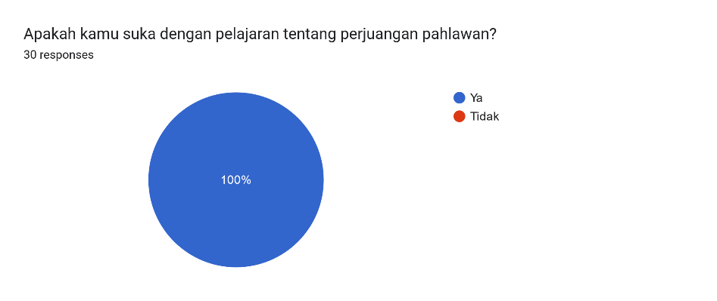
Based on the data above, 100% of grade 4 students at SDN Panaragan 1 Bogor City said they liked the lesson about the struggles of heroes. This shows that a sense of nationalism exists in students.
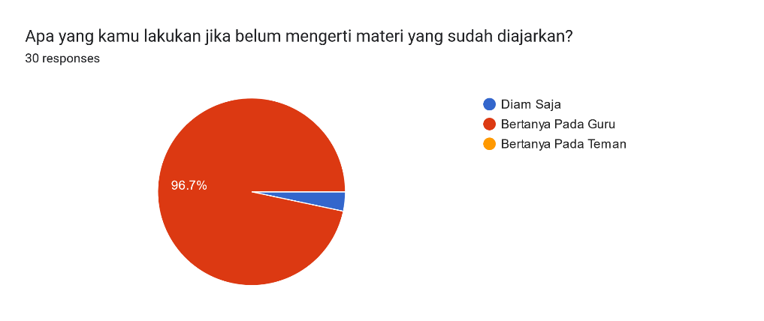
Based on these data that there are 96.7% of students will ask the teacher if they do not understand the material that has been taught. Meanwhile, 3.3% stated that they would remain silent if there was material they did not understand. This shows that their level of thinking is critical so that if they are not understood, they are asked directly by the teacher.
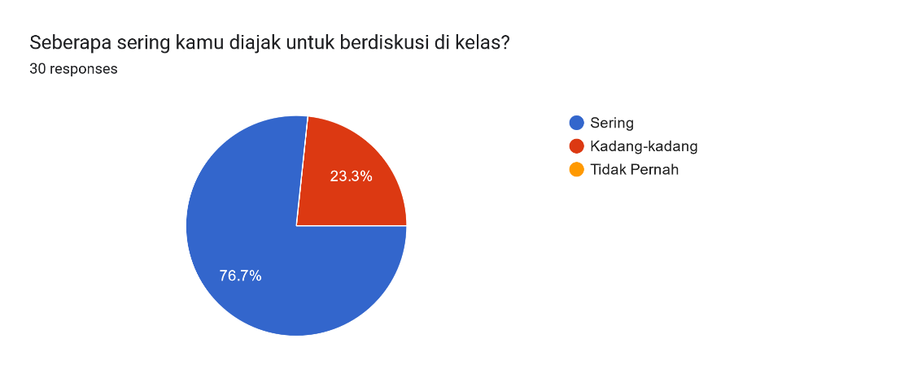
Based on these data it can be seen that 76.7% of students are often involved in discussions in class so that cooperation, cooperative and collaborative can be well established. Meanwhile, 23.3% indicated that students were sometimes invited to discuss in class.
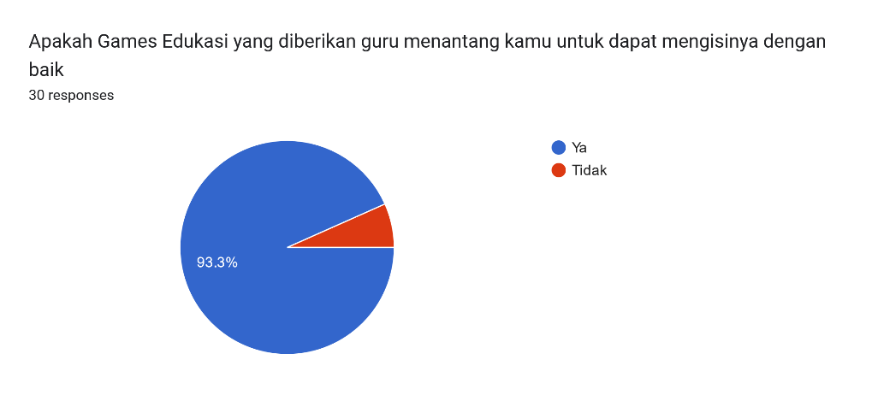

Based on these data 93.3% of students stated that the educational games provided by the teacher challenged them to be able to fill them properly. Moreover, games are made in the form of a maze that challenges students to think critically and reason. Meanwhile, 6.7% of students, or a small portion stated that educational games were not challenging for them to be able to fill them properly.
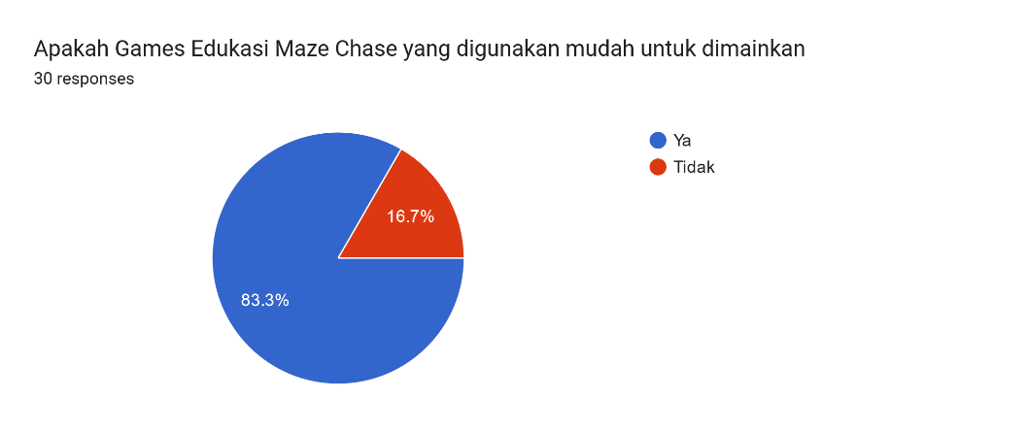
Based on the data above, 83.3% of students stated that the maze chase educational games that were made were easy to use and very fun. Whereas 16.7% of students stated that the maze chase educational game was not easy to use (difficult) so that they failed several times to complete the game.
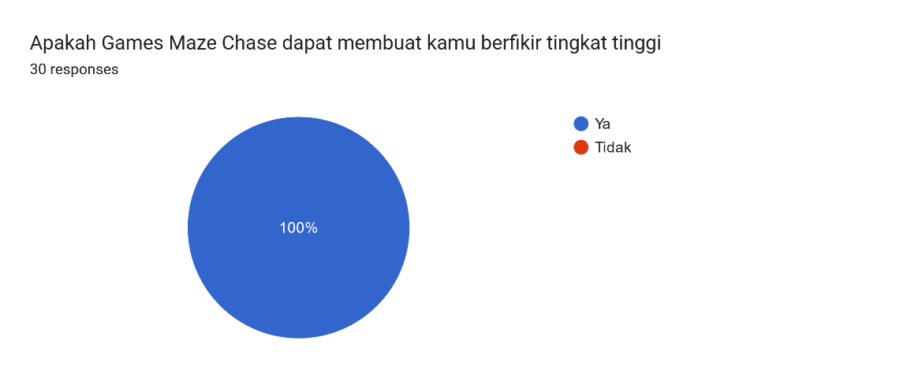

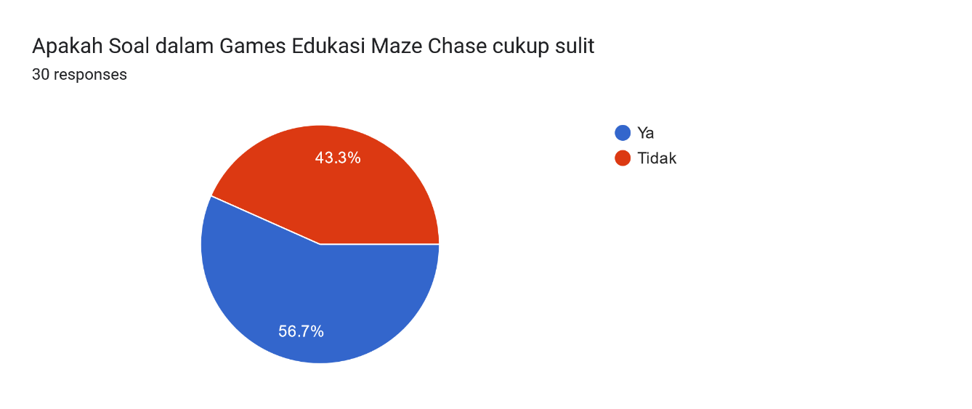
Discussion
Education 5.0 is an umbrella term used by educational theorists to describe various ways of integrating electronic technology, both physical and non-physical, into learning. This is a leap forward from Education 4.0. Education 4.0 encompasses the confluence of neuroscience, cognitive psychology, and educational technology, leveraging web-based digital and mobile devices, including applications, hardware, and software. Education 5.0 is a phenomenon that emerged as an answer to the needs of the 5.0 industrial revolution, where humans and machines adapt to find solutions, solve various problems and discover new possibilities for innovation that can be used to improve modern humans to be better in life (Arjunaita, 2020) Responding to the challenges of the Industrial Revolution 4.0 and Society 5.0 in the field of education requires 21st Century Life Skills or better known as 4C (Creativity, Critical Thinking, Communication, and Collaboration). It is hoped that teachers will become creative individuals who are able to teach, educate, inspire and set an example (Nurani, 2021)
Society 5.0 is a society that is able to solve various challenges and social problems by utilizing various innovations that were born in the Industrial Revolution 4.0 era, such as the Internet of Things (Internet of Everything), Artificial Intelligence (Artificial Intelligence), big data (in large quantities). data) and robotics to improve the quality of human life. Society 5.0 can also be interpreted as a human-oriented and technology-driven social concept. As educators in the era of society 5.0, teachers must have skills in the digital realm and think creatively. Teachers must be more creative and dynamic in teaching in class.
The teaching skills needed today are mainly related to instructional media. The word media comes from the Latin medius which literally means 'middle', 'middle ground' or 'foreground'. According to Gerlach and Eli V Arsyad, media in a broad sense are humans, material or events that create conditions for students to acquire knowledge, skills or attitudes (Arsyad, 2019). More specifically, the concept of media in the teaching and learning process is often interpreted as a graphic, photographic or electronic tool for capturing, processing and reconstructing visual or verbal information.
According to Munadi, (2020) educational media is anything that can convey and channel messages from sources in a planned manner to create a conducive learning environment where recipients can carry out the learning process efficiently and effectively. Learning media is defined as resources in the form of physical or non-physical which are deliberately used as mediators between teachers and students in understanding educational material to make it more effective and efficient. ((Musfiqon, 2012) so that educational material is more quickly accepted by students as a whole and students' interest is stimulated to continue learning.
Based on the description above, researchers can synthesize that learning media is an integral part of the teaching and learning process to achieve predetermined educational goals, and learning media can also arouse student interest and learning outcomes.
1. Media functions in the learning process.
The term media is very popular in the field of communication. Media is a learning tool that can be used as a messenger in a learning activity. Learning media has several functions that support the teaching and learning process. According to Kemp and Dayton (Sundayana, 2016),, there are three main roles in media studies as follows.
  - To motivate interest or action, to play a motivational role, educational means can be created in theatrical or entertainment techniques.
  - Presentation of information, content, form of presentation is very common, serves as an introduction, synthesis or motivation of knowledge or techniques.
  - Didactic education, for teaching purposes where information in the media must involve students mentally or mentally as well as in the form of real life activities to enable learning to occur.
Based on the description above, the role of learning media is to stimulate interest or action, present information, content, general forms of presentation, and provide instructions.

2. Terms and Criteria for Learning Media
The selection of learning resources to be used must be based on clear intentions and choices. The selection of media must be in accordance with the conditions and standards of learning media, so that learning media can be used properly and support the teaching and learning process.
According to Raharjo in Mulyana (2016) the requirements and standards for learning about media are as follows.
  - The purpose of the election itself should be clear.
  - Familiarity with the media, such as the properties and characteristics of the media, must be acknowledged.
  - Selection should be based on several criteria such as guidelines and benchmarks
  - Given the large number of media in the learning process, it is felt very necessary to classify different learning media so that it is easier to understand the principles of using, maintaining, and selecting media in the learning process.
According to Sanjaya in Sundayana (2016) the types of props are as follows.
  - Mobile audiovisual media, such as sound films, video cassettes, film reviews, television, and animation.
  - Silent audiovisual media, such as sound films, sound pages, and sound slides.
  - Semi-motion audio such as voice-distance writing.
  - Transfer of visual media, such as silent films.
  - Still visual media, such as printed pages, still images, such as printed pages, photos,
  - microphone.
  - Audio media such as radio, telephone, and cassette.
  - Print media, such as books, modules, self-study materials
Educational learning games are learning multimedia that can support the learning process in the classroom. Educational games are games that aim to stimulate students' interest in learning. Learning becomes more interesting and not boring, students need to think while playing, s students have critical thinking. The statement above is in line with the views of Kemp and Dayton and Dayton in Faiq (2012) that the benefits of games when, when used as learning media,s follows: 1) standardization of the content provided; 2) making the learning process more interesting; 3) making learning more; 4) learning time becomes efficient; 5) improve the quality of education; 6) the learning process becomes more flexible; 7) promote a positive attitude towards the learning delivered.
Games are works of art where players make decisions to get what they have through game features to complete objectives. This means that each educational game contains learning activities designed to attract students' attention so that students can learn and play according to the educational goals to be achieved. Games allow students to learn while having fun to get entertainment so students don't get bored with the learning presented.
According to Samuel Putra et al., (2020)), the benefits of games are beneficial for children, stating: 2) Learn to follow directions and rules. 3) as a logical way of solving problems; 4) motor nerves and spatial skills. 5) Establish communication between children and parents when talking. 6) As a means of entertainment. 7) For some people, games should be used as therapy.
Playing is an activity that is not only liked by children but also by adults. Most popular games are those that are distributed on computers and gadgets. However, games have a negative image for most seniors. The only way out is to study because these games can lead to addictive behavior and a tendency for children to do nothing else. Many friends in the field with many participants teach school and go to PlayStation stalls and cafes to play online. Digital offers possibilities to help students learn. This statement is based on research showing the positive impact of playing games. Fadhilaturrahmi et al., (2021) games allow children to expend excessive physical and emotional energy.
Tias in Wahyuni & Usman (2020) state that a labyrinth is a labyrinth game that requires children to think effectively and choose their path among the many available methods.
Wahyuni & Usman (2020) Labyrinth is a prayer learning activity and children must have a line that they must traverse through parts of the maze to complete it. Istiati said finding a way or maze game is a narrow path, winding and turning and sometimes a dead end, or a gravel road, through obstacles to see through educational games.
Thinking includes mental activity in problem criticism, analysis of results, analysis, learning and acquisition. The ability to search, analyze and analyze information is very important in decision making. Critical thinkers seek information, analyze, analyse, draw conclusions and make decisions based on facts. The characteristics of people who think critically are always visible and show a relationship with the issue or issues that are being discussed in other relevant experiences (Kurniawan, N. A., Saputra, R., Daulay, A. A., 2020) belief or the right decision for what Siswono is doing ( 2016) The process of critical thinking includes: 1. Understanding the situation 2. Understanding opinions based on evidence, data, or expectations 3. Providing arguments beyond evidence 4. Conclusions/decisions/solutions 5. Accepting conclusions/decisions/settlements.
Critical thinking is students' critical thinking skills in oral form, presentations, analysis and problem solving (Saputri, 2020). Fogarty and McTighe's (1993) critical thinking is a way of thinking that is rational or based on reason, reflective, rational or relaactive about what must be done or what is needed (Diharjo & Utomo, 2017)
Incendiary is an act of thought that is superior to ordinary thought. Mother tongue is carried out through a certain process to reach conclusions (Mulyati, 2019) especially in the process of students' mother tongue at the everyday school level. Suherman (2013) Thinking can be seen as developing the ability to solve information problems and develop the ability to express ideas (Arianto et al., 2019).

CONCLUSION
Current learning requires the use of interactive and innovative learning media. Maze Chase Learning Media is one of the learning media that can be used as a solution in forming students' critical thinking skills. Apart from having to answer the questions, there is an element of how to trick them so they are not confronted by the enemy. With maze chase learning media it is appropriate to use it as a learning medium in elementary schools.
ACKNOWLEDGMENTS
We express our gratitude to the Pakuan Siliwangi Foundation, Pakuan University, LPM Pakuan University, SDN Panaragan 1 Bogor City, which has funded and facilitated researchers in carrying out Pakuan University Internal Research Grants.

REFERENCES
Arianto, A. S., Sulianto, J., & Azizah, M. (2019). Analisis Kemampuan Penalaran Matematis Siswa Kelas Iv Sdn Gayamsari 02 Di Kota Semarang. Jurnal Sinektik, 2(2), 136. https://doi.org/10.33061/js.v2i2.3327
Arjunaita. (2020). Pendidikan di era revolusi indiustri 5.0. Prosiding Seminar Nasional Pendidikan Program Pascasarjana Universitas PGRI Palembang, 2, 179–196.
Arsyad, M. N. (2019). Penerapan Model Pembelajaran Visualization Auditory Kinestetic (Vak) Dalam Meningkatkan Hasil Belajar Ips Siswa Smpn Moncok. Maharsi, 1(02), 1–11. https://doi.org/10.33503/maharsi.v1i02.528
Diharjo, R. F., & Utomo, D. H. (2017). PENTINGNYA KEMAMPUAN BERFIKIR KRITIS SISWA. 445–449.
Fadhilaturrahmi, Ananda, R., & Yolanda, S. (2021). Jurnal basicedu. Jurnal Basicedu, 5(3), 1683–1688.
Faiq, A. (2012). MATHEMATICS ADVENTURE GAMES BERBASIS ROLE PLAYING GAME (RPG) SEBAGAI MEDIA PEMBELAJARAN MATA PELAJARAN MATEMATIKA KELAS VI SD NEGERI JETIS 1.
Kurniawan, N. A., Saputra, R., Daulay, A. A., & Z. (2020). Implementasi Prinsip-Prinsip Merdeka Belajar Bagi Calon Konselor. Prosiding Seminar Nasional Bimbingan Dan Konseling Universitas Negeri Malang, 69–72.
Mulyana, Y. (2016). Pengantar Pembelajaran Penjas. STKIP Sebelas April Press.
Mulyati, S. (2019). Pengaruh Kemampuan Bernalar dan Penguasaan Kosakata terhadap Kemampuan Menulis Karangan Argumentasi. Diskursus: Jurnal Pendidikan Bahasa Indonesia, 1(01), 67. https://doi.org/10.30998/diskursus.v1i01.3514
Munadi, Y. (2020). Media Pembelajaran. Gaung Persada Press.
Musfiqon. (2012). Pengembangan Media dan Sumber Pembelajaran. Prestasi Pustaka Raya.
Nurani, D. (2021). Menyiapkan Pendidik Profesional Di Era Society 5.0. Direktorat Sekolah Dasar. Direktorat Jendral PAUD Dikdas Dan Dikmen. Kementrian Pendidikan, Kebudayaan, Riset Dan Teknologi. http://ditpsd.kemdikbud.go.id/artikel/detail/menyiapkan-pendidik-profesional-di-era-society-50
Putra, I. K. A. A. ., Suarsana, I. M., & Suharta, I. G. . (2020). Pengembangan Bahan Ajar Interaktif Materi Pecahan untuk Siswa SMPLB Tunarungu dengan Pendekatan Multi Representasi. Jurnal Nasional Pendidikan Teknik Informatika : JANAPATI, 9(01), 69–84.
Saputri, M. A. (2020). Penerapan Model Pembelajaran Problem Based Learning Untuk Meningkatkan Kemampuan Berfikir Kritis Siswa Kelas V Sekolah Dasar. Jurnal Pendidikan Dan Konseling (JPDK), 2(1), 92–98. https://doi.org/10.31004/jpdk.v1i2.602
Sugiyono. (2016). Metode Penelitian Pendidikan. IKAPI.
Suherman, S. (2013). Proses Bernalar Siswa Dalam Mengerjakan Soal-Soal Operasi Bilangan Dengan Soal Matematika Realistik. JIPM (Jurnal Ilmiah Pendidikan Matematika), 1(2), 1–9. https://doi.org/10.25273/jipm.v1i2.468
Sundayana, R. (2016). Media dan Alat Peraga dalam Pembelajaran Matematika. Alfabeta.
Wahyuni, S., & Usman, J. (2020). Penerapan Permainan Maze dalam Pembelajaran untuk Pengembangan Kognitif Anak di TK PKK Jalmak Desa Jalmak Kecamatan Pamekasan Kabupaten Pamekasan Jawa Timur. Kiddo: Jurnal Pendidikan Islam Anak Usia Dini, 1(2), 160–173. https://doi.org/10.19105/kiddo.v1i2.3687

