TEACHING STUDENTS SPEAKING SKILL THROUGH FISHBOWL TECHNIQUE ON SUBJECT OF ENGLISH FOR TOURISM

Acep Haryudin¹, Aseptiana Parmawati²

¹English Education Department of IKIP Siliwangi
²English Education Department of IKIP Siliwangi
¹haryacep@gmail.com, ²aseptianaparmawati@gmail.com

Abstract
The ability to speak is the main basis that must be possessed by every student, especially for students who majored in English education. However, most problems in the process of teaching English are closely related to the ability to speak itself. The formulation of the problem in this study are; is there a significant improvement in speaking skills when applying the fishbowl technique to the English for Tourist Guide course? and What are the classroom situations and conditions when the fishbowl technique is applied in the learning process in the English for Tourist Guide course? Therefore, the long-term goal of this research is to produce learning theories that can be applied by lecturers without changing their roles but can optimize the creativity and ability of students in good English and in accordance with applicable language rules. This research method is quantitative research and the design used in this study is Classroom Action Research (CAR) which consists of several cycles with a sample of one class, namely class A3 2016 IKIP SIliwangi. The results and conclusions in this study are the sum of all student scores in the pre-test is 122, and the total score in session 1 is 154, while the score in session 2 is 187, after averaged, the scores obtained are 4.5 for the scores pre-test, 5,7. for the value of session 1, and 6.9 for the value of session 2 from the analysis made, it can be concluded that the results obtained have not demonstrated the success of Fishbowl learning conducted by lecturers / researchers. Looking at the comparison of initial values, the value of the first cycle and the value of the second cycle, there was a significant increase, namely from the average initial value of 4.5 rising in cycle I to 6.3 and in cycle II rising to 7.9 This increase could not underestimated because this increase in value is from the maximum efforts carried out by researchers for the sake of improving the quality of education and the advancement of education, especially in English Language Study Program IKIP Siliwangi.
Keywords: Fishbowl Technique, Speaking Skill, Classroom Action Research (CAR)
Abstrak
Kemampuan berbicara adalah dasar utama yang harus dimiliki oleh setiap siswa, terutama bagi siswa yang mengambil jurusan pendidikan bahasa Inggris. Namun, sebagian besar masalah dalam proses pengajaran bahasa Inggris terkait erat dengan kemampuan berbicara itu sendiri. Rumusan masalah dalam penelitian ini adalah; apakah ada peningkatan yang signifikan dalam keterampilan berbicara ketika menerapkan teknik fishbowl ke kursus Bahasa Inggris untuk Panduan Wisata? dan Bagaimana situasi dan kondisi kelas ketika teknik fishbowl diterapkan dalam proses pembelajaran dalam kursus Bahasa Inggris untuk Panduan Wisata? Oleh karena itu, tujuan jangka panjang dari penelitian ini adalah untuk menghasilkan teori pembelajaran yang dapat diterapkan oleh dosen tanpa mengubah peran mereka tetapi dapat mengoptimalkan kreativitas dan kemampuan siswa dalam bahasa Inggris yang baik dan sesuai dengan aturan bahasa yang berlaku. Metode penelitian ini adalah penelitian kuantitatif dan desain yang digunakan dalam penelitian ini adalah Penelitian Tindakan Kelas (PTK) yang terdiri dari beberapa siklus dengan sampel satu kelas, yaitu kelas A3 2016 IKIP SIliwangi. Hasil dan kesimpulan dalam penelitian ini adalah jumlah dari semua skor siswa di pre-test adalah 122, dan skor total di sesi 1 adalah 154, sedangkan skor di sesi 2 adalah 187, setelah rata-rata, skor yang diperoleh adalah 4,5 untuk skor pre-test, 5,7. untuk nilai sesi 1, dan 6,9 untuk nilai sesi 2 dari analisis yang dilakukan, dapat disimpulkan bahwa hasil yang diperoleh belum menunjukkan keberhasilan pembelajaran Fishbowl yang dilakukan oleh dosen / peneliti. Melihat perbandingan nilai awal, nilai siklus pertama dan nilai siklus kedua, terjadi peningkatan yang signifikan, yaitu dari nilai awal rata-rata 4,5 naik pada siklus I menjadi 6,3 dan pada siklus II naik menjadi 7,9 ini. Peningkatan tidak dapat diremehkan karena peningkatan nilai ini berasal dari upaya maksimal yang dilakukan oleh peneliti demi meningkatkan kualitas pendidikan dan kemajuan pendidikan, terutama di Program Studi Bahasa Inggris IKIP Siliwangi.
Kata kunci: Teknik Fishbowl Keterampilan berbicara, Penelitian Tindakan Kelas (PTK)

INTRODUCTION
The Department of English Language Education is one of the departments in IKIP Siliwangi which aims to produce graduates with a Bachelor of English Language qualification (S1). English students themselves are required to have the ability to speak, especially in the English for Tourist Guide course. The ability to speak is a basic ability that must be possessed by every student as a provision in facing challenges in future competition.
According to Sartika, D. (2016) argues that "speaking is a fundamental ability, the main purpose in speaking is to get a response from the listener, to convey something scientific or other things, to get information, ask questions or even ask for something".
However, students' ability to speak English at IKIP Siliwangi is still lacking. The skill of speaking in a foreign language is still considered a very difficult skill to be mastered by students. Problems often faced by students in speaking English in the English for Tourist Guide course include (1) students who are less active in classroom learning, (2) limited vocabulary mastery, (3) lack of use of methods or techniques interesting learning. This is in line with the findings we obtained from the value of speaking practice as a tour guide in the English for Tourist Guide course in the academic year 2017/2018 is as follows:

Table 1
Percentage of Speaking Practice Scorring
in English for Tourist Guide Academic Year 2017/2018
Class | Sum of Students | Precentage Scorre  ≤ 60 | Precentage Scorre  > 60
A1 | 40 | 80% | 20%
A2 | 38 | 78,94% | 21,06%
A3 | 40 | 87,5% | 12,5%

Referring to these findings, we are very interested in conducting a Classroom Action Research (CAR) on students' speaking skills, which focuses on English for Tourist Guide teaching materials by applying the fishbowl technique.
The Problem Formulations in this study are; 1) Is there a significant improvement in speaking ability when applying the fishbowl technique in the English for Tourist Guide course? 2) what are the classroom situations and conditions when the fishbowl technique is applied in the learning process in the English for Tourist Guide course? while the purpose of this study is 1) to prove the effectiveness of the fishbowl technique in improving students' speaking skills in the learning process of the English for Tourist Guide course. 2) to know the class situation and conditions when the fishbowl technique is applied in the learning process in the English for Tourist Guide course.

A. Definition of Teaching Speaking
Teaching the ability to speak to students, has an important role in understanding English as a foreign language because if students are able to speak well, this means students have been able to master the language being studied. Not only is learning serious and focused, but passion and strong encouragement can help students to be able to follow a good learning process. Most students, mastering the art of speaking as a major aspect of learning English as a second language or foreign language, where the level of success is measured by their ability to have English conversation in everyday life.
According to Harmer, J. (2007) said that there are three important reasons to encourage students to be able to speak in front of the class. First, speaking provides opportunities and challenges to face real life, where the initial practice is done in the classroom. Second, in practice speaking in all languages learned, will get feedback directly by the lecturer / lecturer who teaches. Each student can see how far their abilities are, along with what problems they face when learning a language as experience. Finally, every student has the opportunity to be more active in learning activities, as well as in learning the elements that form a language, which is already in their brain, so that this ability will automatically be used directly.

1. Types of speech
According to Kusmaryati, S. (2009), there are six categories that include the ability to speak, including:
- Imitating
In this category, there is the ability to practice an innovation and focus on the elements forming language elements. At this stage what is done is only imitating a word, phrase, or sentence. The most important thing at this stage is to focus on pronunciation (pronunciation). Teachers provide training directly on learning activities. It is intended that students receive the opportunity to listen and practice their pronunciation directly.
- Intensive Ability
At this stage students learn and practice aspects of sound (phonological) and structure (grammatical) as aspects of language. This teaches students to do assignments in teams.
- Responding Ability
The ability to respond includes interacting and understanding tests, but is limited by the level of short speeches, greeting sentences and short conversations, requests and concise comments.
- The ability to provide responses
At this stage the aim is to convey and exchange certain information. An example is a conversation that is done in groups.
- Interpersonal relations skills
At this stage the goal is more about the ability to maintain social relations than the delivery of facts and information. The forms of the practice of speaking itself include interviews, role playing, discussions, conversations and games.
- Extensive ability
Teachers provide opportunities for students to practice speaking through self-speaking exercises using material in the form of oral reports, summaries, and retelling a story.

2. Elements of speaking
According to Rahmawati, R. (2017) in general there are several elements in speaking mastery that must be mastered by students, including:
The component is what aspect influencing how well people speak English. Here is the component of speaking skill according to syakur.According to Syakur (1987: 5), speaking is a complex skill because at least it is concerned with components of grammar, vocabulary, pronunciation, and fluency.

1) Grammar
It is needed for students to arrange a correct sentence in conversation. It is in line with explanation suggested by Heaton (1978: 5) that student’s ability to manipulate structure and to distinguish appropriate grammatical form in appropriate one. The utility of grammar is also to learn the correct way to gain expertise in a language in oral and written form.

2) Vocabulary
Vocabulary means the appropriate diction which is used in communication. Without having a sufficient vocabulary, one cannot communicate effectively or express their ideas in both oral and written form. Having limited vocabulary is also a barrier that precludes learners from learning a language. Language teachers, therefore should process considerable knowledge on how to manage an interesting classroom so that the learners can gain a great success in their vocabulary learning. Without grammar very little can be conveyed, without vocabulary nothing can be conveyed.
3) Pronunciation
Pronunciation is the way for students’ to produce clearer language when they speak. It deals with the phonological process that refers to the components of a grammar made up of the elements and principles that determine how sounds vary and pattern in a language. There are two features of pronunciation; phonemes and supra segmental features. A speaker who constantly mispronounces a range of phonemes can be extremely difficult for a speaker from another language community to understand (Gerard, 2000:11).
4) Fluency
Fluency can be defined as the ability to speak fluently and accurately. Fluency in speaking is the aim of many language learners. Signs of fluency include a reasonably fast speed of speaking and only a small number of pauses and “ums” or “ers”. These signs indicate that the speaker does not have to spend a lot of time searching for the language items needed to express the message (Brown. etl 1983: 4).

B. Fishbowl Technique
Fish Bowl Technique is a way to discuss through large groups. This technique is used to verbally interact in the classroom which is expected to be an interaction between class members to share knowledge and opinions.
Khadija. (2014), argues that Fishbowl is a communicative game that can be used as a technique in learning. According to Miller (2010) cited by Aswadi, J., & Akhmad, H. (2016) in his study found that the fishbowl technique can encourage English language proficiency of students and Lee, Chen & Chao (2011) cited by Aswadi, J., & Akhmad, H. (2016) also found that interest in learning can influence the results of the teaching and learning process. while according to Andika (2013) in Aswadi, J., & Akhmad, H. (2016) in his study found that fishbowl techniques and student motivation can improve student speaking achievement.

The procedure in applying FishBowl Technique according to Yabarmase, D. (2014) is as follows:
- Identify the theme to be discussed.
- Asking students to participate in giving ideas and opinions related to the theme. Remind students to record the results of their discussions.
- Practice the ways and steps in using FishBowl Technique.
- Begin the discussion by arranging the sitting members of the discussion in advance based on the arrangement of the outer or inner ring.
- Ask other students to listen carefully when their friends are in the circle in the discussion, and note down questions that will be asked.
- The teacher makes sure the discussion goes well, by ensuring that each member participates and takes turns taking part.
- When group members in the inner circle finish having a discussion, the teacher asks other students to comment or even ask questions that are in accordance with the results of the discussion.
- Repeat these steps until all students have the opportunity to be in the inner circle, so that they understand the learning using the technique

C. Speaking Ability in English for Tourist Guide Courses
The English for Tourist Guide course is a subject that must be taken by the 5th semester students at the IKIP Siliwangi campus. Speaking skills are the main reference in providing final assignments for students. This is in accordance with the CP in the syllabus and RPS of the English for Tourist Guide course where students are expected to be able to speak as speakers of a foreign language that is English, and perform role play as a tour guide.

METHOD
The method used in this research is a quantitative method with Classroom Action Research (CAR) approach. This research was conducted at IKIP Siliwangi, located at Jl.Terusan Jenderal Sudirman No.3, Baros Cimahi Tengah, West Java. The subject of the study was the 5th semester students who took the English for Tourist Guide course, which would be randomly selected. This research used a research design in the form of Collaborative Classroom Action Research. The concept in this study is adapted from Anne Burn (2009) which applies 4 components, namely planning, implementation, implementation, and reflection.
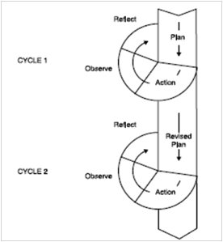

Figure 01.
CAR procedure

The formula for retrieving data values is as follows:

M = Average scorre
= Total score
N = Total of Students

Sumber [9]

D. Data collection techniques
Data collection techniques in this study used observation, interview, questionnaire, and test techniques.
In collecting this data, it will be grouped based on research stages consisting of several cycles, so that it will be easier for researchers in the process of compiling the results and making final conclusions.

Table 3.2
Data collection technique
Technique | Target | Objectives | Data
Observasion | Students and Lecturer | To find out each set of learning activities | Short notes of Lecturer
Interview | Students and  Collaborator | To find out the interactions between participants in research | Interview (sum note)
Questionnaire | Students | To determine the response of students indirectly to the course of learning activities | Percentage of questionnaire scores
Test | Students | To get information about the values before and after the application of the fishbowl technique | Scorring

E. Data Analysis
This study has two cycles, and the data obtained in each cycle (action) will be analyzed quantitatively and qualitatively to determine the final results of an action. Qualitative data on student learning outcomes will be analyzed descriptively by finding the average scores of students' success both in pre-test and post-test. Evaluation data will be analyzed using descriptive analysis by finding the average value of student success both in pre-test and post-test. Namely by using the following steps:
1. The value of each student answering the test in each meeting.
2. Data is calculated using the following formula:

M = Average scorre
= Total score
N = Total of Students

Sumber [9]

Meanwhile, qualitative data obtained through observation sheets were analyzed so as to provide an overview of the level of understanding of the lesson, attitudes or views of students towards the learning methods applied, student activities in following the lessons, attention, enthusiasm in learning, self-confidence, learning motivation, and the like is analyzed qualitatively. This analysis will be carried out from every first and subsequent cycle.

RESEARCH METHOD
A. Research settings
This research was conducted in class A3 2016, IKIP SIliwangi English Language Education Study Program. This place was chosen because based on the results of classroom observations and interviews with English lecturers in the class it can be concluded that the students' listening skills in English are still low. This is due to the fact that lecturers do not use adequate techniques, the limited number of books available in schools and the lack of media equipment.
B. Research Subjects
The subjects in this study were all students of the A1 2016 2016 English Education Study Program. The total number of students consisted of 57 people, consisting of 46 female students and 11 male students. 7 female students have relatively good abilities in speaking English, 10 people have moderate abilities, and 29 people have very weak abilities. 5 male students have relatively good abilities in speaking English. 4 people have moderate ability, and 2 people are very weak in speaking English.
C. Data Sources
The data from this study were sourced from students and lecturers. Data from students is the results of tests, both initial and final tests that can be observed directly by researchers, and activities in the learning process. Data from lecturers is the result of observations made by researchers while the teaching and learning process is ongoing as additional data in this study.

RESEARCH RESULT
A. Research Results
In this section the researcher conveyed the data obtained from this action research in detail based on research conducted at IKIP Siliwangi class A1 class of 2016. Before presenting the results of the research it is worth looking at the opinions of the following educational experts: in presenting the results of research and discussion, it is necessary presents a description of each cycle with complete data ranging from planning, implementation, observation and reflection which contains an explanation of aspects of success and weaknesses that occur. Fundamental things need to be added, namely the results of discussion (progress) on students, the environment, lecturers, motivation and learning activities, class situations and learning outcomes, noting graphs and tables of results of data analysis that show the changes that occur accompanied by systematic and clear discussions ( Suharsimi Arikunto, Suhardjono, Supardi, 2006: 83).
In this study the researcher presents the complete data from what was made according to plan, what the results are, how they are implemented, what has been achieved, to the reflection. For more details can be seen as follows:

1. Action Plan I
The results obtained from planning activities include:
- Compile the next action plan complete with RPS that will be implemented using the Fishbowl technique
- Determine the time of implementation, which concerns the day, date, according to the research schedule, namely the month of March 18, 2019
- Ask other lecturers as a collaborator team in this study in implementing learning using Fishbowl that has been planned.
- Carry out supervision of class visits in observing the existing deficiencies.
- Develop a check format related to fishbowl learning.
- The team of collaborators who were asked to observe the learning were given a briefing about the fishbowl learning model by:
  - The team of collaborators as supervisors are notified in advance and know the learning methods using Fishbowl and their presence in class is not looking for mistakes, but for the common interest of improving learning.
  - The team of collaborators as supervisors have been told to better understand the principles of supervision so that they no longer tend to be instructive and more friendly to the principle of peer care.
  - In the implementation of supervision, the team of collaborators as supervisors are expected to show a close sense of collegiality and are willing to assess the truth.
- The researcher gives an explanation to the students that the presence of supervisors to the class is not to look for mistakes or weaknesses of researchers / lecturers in learning, but to improve the ability of students to master knowledge.
- Plan lesson material and formulate goals. Determine the lesson material, by adjusting to the applicable syllabus and the translation is quite good.
- Select and organize material, media, and learning resources.
In this first cycle, researchers organized learning materials well. The order of delivery from easy to difficult, the scope of the material is quite meaningful for students, determining teaching aids. Whereas in determining the source of learning has been adjusted to the objectives, learning materials and the level of student development.
- Designing learning scenarios.
Learning scenarios are adjusted to the objectives, material and level of development of students, sought variations in the delivery. The composition and steps of learning have been adjusted to the objectives, material, level of development of students, the time available, systematically is to place students in a central position, to follow changes in educational strategies from teaching to learning according to Ministry of Education Decree No. 41 of 2007 and adjusts to the Fishbowl learning model.

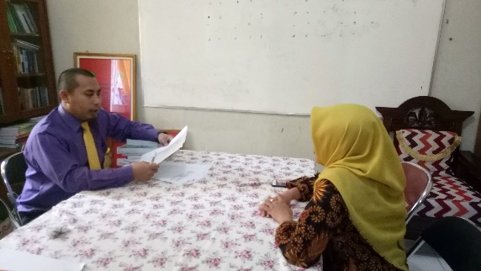 | 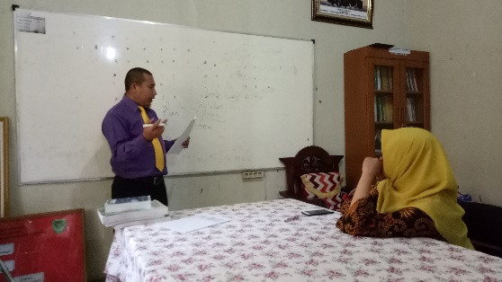

Figure 02.
Cycle Planning Process I
2. Implementation of Actions I
- Class management
Manage classes with careful preparation, teach materials correctly according to the Fishbowl learning model.
- Assessment Tool
Discussion and type of assessment, attached to the RPP along with the assessment format.
- Appearance
Appearance in general, researchers dress neatly, use polite language, guide students as much as possible with the use of the Fishbowl learning method. Researchers strive for strategies to easily observe students who are learning. After learning is done, it is continued by holding a meeting with the lecturer / collaborator team who oversees the learning process to discuss the results of observations made.
- From discussions with the lecturer / collaborator team, it was revealed that:
- Learning is not optimal, because new researchers first try this method.
- Students are indeed not actively accepting lessons and responding, this is in accordance with the objectives of the Fishbowl method.
- The researcher proposes that the observing team / lecturer team wants to return and is willing to look again at the opportunity in cycle II.
- For a while, researchers were not convinced that the implementation of class visit supervision would help improve students 'abilities, but according to the observers' thinking, the method used by researchers was quite able to encourage increased creativity and learning achievement.
- Submission of observers to researchers can be delivered such as Need to manage space, time, and better learning facilities. In managing classrooms, time and learning facilities, it can be explained as follows:

  - Researchers provide learning aids / media.
  - Researchers pay less attention to the cleanliness of the blackboard, the cleanliness of student uniforms, in other cases that are useful to foster student motivation and discipline.
  - Researchers haven't been so good in time. Starting lessons are not timely due to certain things.

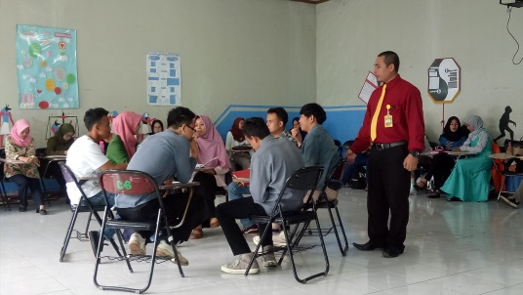 | 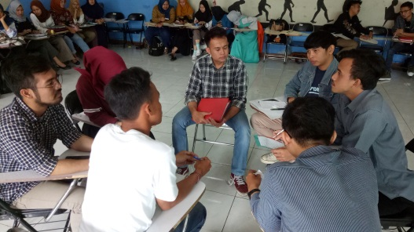

Figure 03.
Cycle I Implementation Process
5. Observation / Observation Cycle I
Observations vary. Researchers use lecturers / collaborators to enter the classroom to observe the truth of the implementation of learning using the Fishbowl model. Data obtained from observations conducted by lecturers will greatly affect the progress of researchers in applying the Fishbowl learning model given that all the weaknesses of researchers will be observed properly. When researchers relate to the so-called interrupting variable or intervening variable where there are certain things that can affect the relationship between the independent variables, namely the Fishbowl learning model with the dependent variable, namely the learning pretensions. The particular thing that was discussed was the correct implementation of the Fishbowl learning model. If the implementation is not correct it will certainly affect the learning outcomes.
Observations by peers as described above are very necessary for the success of improving the quality and correctness of learning of the Fishbowl model. The researchers did this for the sake of innovation efforts so that this article is more efficient and effective.
In addition to observations made by peers, another effort the researcher made was to instruct one of the students who was clever to check whether the implementation of Fishbowl learning in the class had gone as expected or not. Both the lecturers who watched, and students who were told to observe the activities of their friends. Fishbowl that demands creativity; self-discovery by students; emphasis on intellectual activity; processing learning experiences into something meaningful in real life; accustom students to be more productive, analytical, critical; the use of methods, techniques, and strategies that enable students to find and find answers themselves optimally is more communicative and able to express their opinions.
In addition, this model requires problem solving skills to increase intellectual satisfaction, sharpen the memory process for longer mastery, more student-centered learning, development of self-concept and academic talent, avoid memorization of learning, foster the ability to assimilate and accommodate information. Learning steps are: a) formulating questions to be able to conduct research, b) checking whether student observations can answer questions, c) collecting data / information, d) analyzing information, e) making conclusions based on the results of information analysis. Of all the above meanings, researchers have prepared instruments for the correct implementation carried out by lecturers and students who observe the learning process.

6. Reflection on Cycle I
Before starting reflection, it's good to see the opinions of educational experts about what is meant by reflection. This opinion is a guide to the ways or things that need to write reflection. Reflection is a comprehensive study of the actions that have been carried out based on the data that has been collected, then an evaluation is carried out to improve the action. Reflection involves the analysis, synthesis, and evaluation of observations of actions taken (Hopkin, 1993 in Suharsimi Arikunto, Suhardjono, Supardi, 2006: 80).
To recapitulate the results of this study will be delivered at the same time at the end of the reflection cycle II analysis. For the results of the analysis of the observations of the team of collaborators and student observations of the correctness of the implementation of learning Fishbowl For the second result of stamping can be conveyed as follows:
1) observations by the team of collaborators in the form of researchers' error notes when carrying out the Fishbowl learning process, this is an invaluable input for improvement in the next cycle, for this more details can be seen in the discussion.
2) for observations made by a team of collaborators it has been seen that the team is capable, the team that has not been able to, clearly shows the activeness, tenacity, creativity, looking for important things assigned, showing the ability of activities, critical, true students who are keen to learn and not lecturer who is active in teaching, ability to show self-concept, speed of responding to demands, ability to produce conclusions.
3) The sum of all student scores in the pre-test was 122, and the total score in session 1 was 154, while the score in session 2 was 187, after being averaged the scores obtained were 4.5 for the pre-test score, 5 .7 for the value of session 1, and 6.9 for the value of session 2 from the analysis made, it can be concluded that the results obtained have not demonstrated the success of Fishbowl learning conducted by lecturers / researchers.

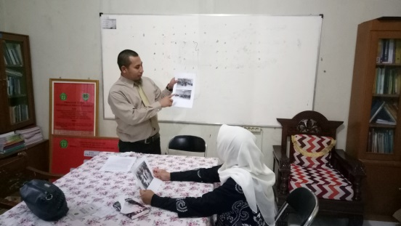 | 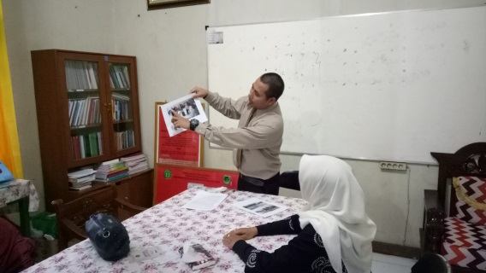
Figure 04.
Cycle I Reflection Process and Plan for Cycle II
1. Planning
Seeing all the results obtained in the first cycle, then for planning the implementation of research in the second cycle there are several things that need to be done, namely:
- Researchers re-plan the schedule for learning in class (cycle II).
- Develop a good learning implementation plan according to the Fishbowl learning model and create a data collection instrument that is a learning achievement test.
- Plan class visits with other observers as an effort to innovate. For this the researcher consulted asking for his willingness to participate in the learning process undertaken. This innovation is carried out so that researchers can make more maximum efforts to carry out better and higher quality learning. The result of consultation with colleagues is the readiness of the lecturer to supervise class visits.
- Together with the lecturer, designing a learning application scenario by looking at the deficiencies that exist in the first cycle by identifying things that can be done to improve learning. For this reason, all notes about deficiencies in cycle I which are the result of reflection are conveyed to the lecturer to be studied. Tell the lecturer what needs to be done, what students have to do, how to apply the correct Fishbowl method according to the correctness of the theory presented.

2. Actions or the Implementation of Cycle II
The implementation of the actions in the second cycle is conveyed as follows:
On a predetermined day according to schedule, the researcher starts the implementation phase of the action by bringing all the preparations that have been made. In accordance with the plan that has been arranged in the form of a learning plan with the application of the Fishbowl technique, the learning steps for understanding the discourse are arranged in steps according with the method applied in this study. The steps are as follows:
The first step, the researcher / lecturer shows the material through a powerpoint slide using infocus, among these materials are some pictures of interesting places, for example mountain places, lakes / valleys, monitor and so on.
The second step is, students are asked to observe and choose a place if if they are given the opportunity to be visited, then they must state the reason. students are given a few moments to convey their reasons for choosing the location.
The third step, students are given time to give their reasons without using notes and are required to use full English. And the fourth step, students are given several questions given in the middle of their discussion.
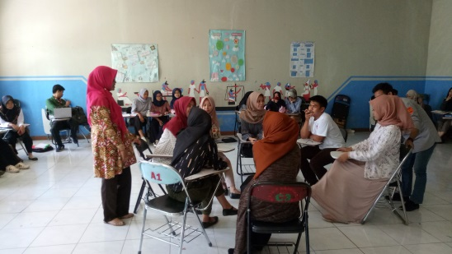 | 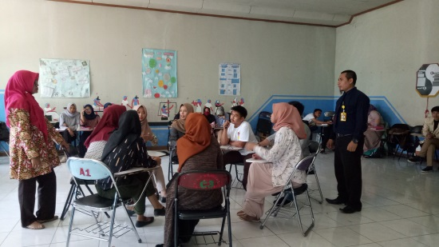
Figure 05.
Cycle II Implementation Process

3. Observation
An assessment of the correctness of the implementation of Fishbowl learning is preceded by noting important things such as learning activities carried out when the researcher takes action. From these quick notes the researcher knows which parts must be corrected, where the emphasis is needed, in which part it is necessary to give suggestions as well as reinforcement. In addition, the presence of a lecturer who observes the learning process will be very helpful to know more clearly the mistakes made during the learning process. Observing lecturers also noted student creativity, student willingness to participate in learning, contributions among students. All of these well done. The learning achievement test was finally resumed next week because after the lecturer conducted the learning process, the time to give the test was not sufficient so it was carried out at the next meeting. The results of the second cycle student learning achievement test will be discussed in reflection II. At the time of observation, researchers and collaborators also observed the learning process.

4. Reflection Cycle II
The results obtained from the learning achievement test in cycle II show that the ability of students to take lessons is quite good and shows that the Fishbowl method has succeeded in improving students' ability to speak using English. Fishbowl is a suitable model for students if the lecturer wants them to have the ability to create, argue, express opinions straightforwardly, exchange ideas, argue, considering the use of this method is to foster students' intellectual abilities, encourage students to be able to find themselves, put students in a central position and strive for students not to learn by memorization.
The results of this study turned out to have given the main effect that the model applied in the learning process significantly affected student achievement. This finding proves that the lecturer has chosen the right method in implementing the learning process because the selection of methods is something that should not be ruled out. This is in line with the findings of other researchers such as those conducted by Inten (2004) and Puger (2004) which basically states that the learning methods applied affect student achievement.
English subjects emphasize their studies on cognitive, affective and psychomotor aspects as guidelines for students' abilities in terms of mind, behavior and visual ability occupy an important place because they can activate students optimally. Of the scores obtained by students, more than half of students scored 8.5, 13 students received intermediate grades of 8. From this comparison value it can be believed that student achievement can be improved by using the Fishbowl method.
Looking at the comparison of initial values, the value of the first cycle and the value of the second cycle, there was a significant increase, namely from the average initial value of 4.5 rising in cycle I to 6.3 and in cycle II rising to 7.9 This increase could not underestimated because this increase in value is from the maximum efforts carried out by researchers for the sake of improving the quality of education and the advancement of education, especially in English Language Study Program IKIP Siliwangi.

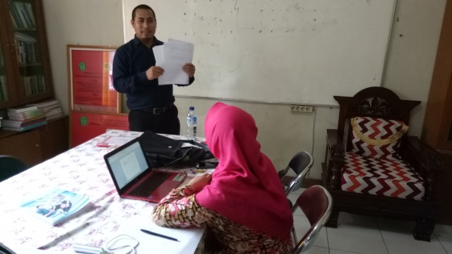 | 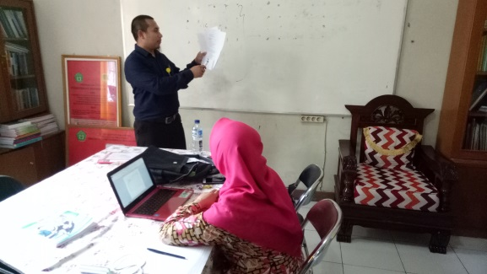
Figure 06
Reflection Process Cycle II

CONCLUSION
Based on the data above, it’s can be concluded that teaching speaking using fishbowl can improve students speaking skill, students can enjoy learning and give them solution to the speaking difficulties before teaching using such method. In teh other words that the results and conclusions in this study are the sum of all student scores in the pre-test is 122, and the total score in session 1 is 154, while the score in session 2 is 187, after averaged, the scores obtained are 4.5 for the scores pre-test, 5,7. for the value of session 1, and 6.9 for the value of session 2 from the analysis made, it can be concluded that the results obtained have not demonstrated the success of Fishbowl learning conducted by lecturers / researchers. Looking at the comparison of initial values, the value of the first cycle and the value of the second cycle, there was a significant increase, namely from the average initial value of 4.5 rising in cycle I to 6.3 and in cycle II rising to 7.9 This increase could not underestimated because this increase in value is from the maximum efforts carried out by researchers for the sake of improving the quality of education and the advancement of education, especially in English Language Study Program IKIP Siliwangi.

REFERENCES
Arikunto, Suharsimi; Suhardjono; Supardi. 2006. Penelitian Tindakan Kelas. Jakarta: PT Bumi Aksara.
Aswadi, J., & Akhmad, H. (2016). Fishbowl Technique and Learning Interest Effects on Speaking Achievement of SMK Sembawa. Jambi-English Language Teaching, 1(1).
Brown. G and G. Yule. 1983. Teaching the Spoken Language; An Approach Based on the Analysis of Conversational English. Cambridge: Cambridge University Press.
Burns, A, Collaborative Action Research for English Language Teachers, New York: Cambridge University
Press. Publisher: Routledge; 1 edition (November 12, 2009)
Harmer, J. (2007). How to Teach English. England: Pearson Education Limited.
Inten, I Gede. 2004. Pengaruh Model Pembelajaran dan Pengetahuan Awal Mahasiswa Terhadap Prestasi Belajar PKn dan Sejarah pada Mahasiswa Kelas II di SMU Laboratorium IKIP Negeri Singaraja. Tesis. Program Pascasarjana IKIP Negeri Singaraja.
Kusmaryati, S. (2009). Improving English Speaking Ability Through Classroom Discussion. Kudus: Undip E-Journal System (UEJS), 6 (1).
Khadijah. 2014. Teaching Speaking Using The Fishbowl Technique. Journal. Banda Aceh: English Education Journal (EEJ), 8(2), 213-221.
Accessed on July 31, 2018.
Rahmawati, R. (2017). Improving Student’s Speaking Ability in Communication Using Direct Method at the Eight Grade of SMPN 3 Darangdan Purwakarta, STKIP SIliwangi Bandung: Paper unpublished
Sartika, D. (2016). Teaching Speaking Using the Information Gap Technique. Journal. Banda Aceh: English Education Journal (EEJ), 7 (3), 273- 285. Accessed on March 5, 2017.
Accessed on April 19, 2016.
Puger, I Gusti Ngurah. 2004. Belajar Kooperatif. Diktat Perkuliahan Mahamahasiswa Unipas.
Yabarmase, D. 2014. Fishbowl strategy: An Effective Way to Improve Students’ Speaking Ability. The 61 TEFLIN International Conference, UNS Solo 2014, 61 (2), 524-526

