THE EFFECTIVENESS OF BLENDED LEARNING IN-TEXT LEARNING OBSERVATION REPORT ON CLASS VI SD STUDENTS
Via Nugraha¹, Asep M Sobur²
¹ IKIP Siliwangi, Cimahi
² SMPN 2 , Cimahi
¹ vianugraha@ikipsiliwangi.ac.id ² asepsobur1969@gmail.com

Abstract
This research was made because of the condition of distance learning which must also be effective in achieving learning objectives. Meanwhile, distance learning that is carried out suddenly makes teachers not maximal in planning and choosing the right method. For this reason, this study tries to implement balanced learning during distance learning with the following objectives: 1) making blanded leaning learning scenarios, and 2) implementing these scenarios in the material of writing an observation report text for grade VI SD. The research method used is qualitative, which describes the phenomenon under study as a whole without seeing any relationship between certain variables. The population used was 110 grade 6 students of SD 010 Cidadap. From this population, 28 students were taken as the research sample. The research was conducted by observing the learning process both online and face-to-face. These observations are also processed data to determine the results of the research. The results showed that the scenario was made based on blended learning, namely two meetings in the network and two face-to-face meetings with attention to pandemic conditions and health protocols. The effectiveness of the implementation was seen based on the observation of each meeting and the writing results of the students who were 85% able to absorb the material well.
Keywords: observation report text, blended learning

Penelitian ini dibuat karena kondisi pembelajaran jarak jauh (PJJ)yang juga harus efektif mencapai tujuan pembelajaran. Sementara itu, PJJ yang dilakukan mendadak membuat guru tidak maksimal dalam membuat perencanaan dan memilih metode yang tepat. Untuk itu, penelitian ini mencoba mengimplementasikan balnded learning selama PJJ dengan tujuan sebagai berikut: 1)membuat skenario pembelajaran blanded leaning, dan 2) mengimplementasikan skenario tersebut dalam materi menulis teks laporan pengataman kelas VI SD. Metode penelitian yang digunakan adalah kualitatif, yaitu mengambarkan fenomena yang diteliti secara keseluruhan tanpa melihat adanya hubungan antara variabel tertentu. Populasi yang dipakai adalah 110 siswa kelas 6 SD 010 Cidadap. Dari populasi tersebut, diambil 28 siswa sebagai sampel penelitian. Penelitian dilakukan dengan car mengobservasi proses pembelajaran baik saat daring maupun tatap muka. Observasi tersebut juga merupakan data yang diolah untuk mengetahui hasil penelitian. Hasil penelitian menunjukkan bahwa skenario dibuat berdasarkan blanded learning, yaitu dua pertemuan dalam jaringan dan dua pertemuan tatap muka dengan memperhatikan kondisi pandemi serta protokol kesehatan. Efektivitas implementasi dilihat berdasarkan observasi setiap pertemuan dan hasil menulis siswa yang 85% dapat menyerap materi dengan baik.

Kata Kunci : teks laporan pengamatan, blanded learning

Introduction
Distance learning was instructed in the Permendikbud in March 2020. According to Ministry of Education and Culture Regulation Number 19 of 2020 and Ministry of Religion Circular Letter number B-699 / Dt.ll / PP.03 / 03/2020, it states that in essence learning cannot be done face-to-face, it must be a distance remote or online to prevent the spread of covid 19. Therefore, learning is carried out remotely online or online.
Distance learning conditions are certainly not the same as face-to-face learning. Many preparations have not been maximal from the teacher, because distance learning has only been implemented this time in a covid-19 pandemic emergency. Meanwhile, learning objectives must be achieved both from the cognitive, affective, and psychomotor aspects. These three goals can be maximized when the teacher delivers material in class. Face-to-face learning in class allows the teacher to stimulate students with problems or findings related to the teaching material. Apart from that, students can also be grouped in various ways so that they can interact with one another. However, in online distance learning, one student with another student does not meet each other and the possibility of interacting with each other is also very difficult. Coordination between teachers and students individually is also not easy, especially from one student to another. This condition allows the amount of student interest in learning to be lost during online distance learning. Network issues and limited device ownership are major obstacles teachers and students face during online distance learning. What's more, the student concerned is still in elementary school.
Elementary school subjects that are now thematic-based still contain separate material elements in them even though they are related to one another. Among these subjects is Indonesian. To achieve the learning objectives, said Juliawati (2015: 2) that in the Indonesian language learning four skills must be mastered by students, namely listening skills, speaking skills, reading skills, and writing skills. The material is writing the experimental report text. Writing is lowering or depicting graphic symbols that describe a language that someone understands so that other people can read the graphic symbols which contain the message the writer carries (Nurhayati, 2019: 81).
The conditions and objectives of learning depend on the teacher when choosing a learning model (Sapdiani, 2019: 30). The model must be following the learning material to be delivered (Sapdiani, 2019: 30). One of the thematic materials in grade VI SD, especially Indonesian, is related to the text of the experimental report. The text is factual (Kosasih, 2016: 44). Meanwhile, Dewi (2015: 3) classifies the text into factual in which there are sub-groups of the report and procedural texts and response texts. Furthermore, Kosasih (2016: 48) explained that the text of the report has text characters that explain a phenomenon as clearly as possible to the reader. The explanation in the text of the administration report aims to provide knowledge or information as clearly as possible to the reader (Prasetyo, 2017: 35).
Because of the need for achievement in these competencies in distance learning, it is necessary to select methods and models to be delivered during learning. During distance learning, the government also provides space for face-to-face meetings with students, although they are not the same as meetings in class. These meetings can be held on a limited basis, following health protocols, and not in the covid-19 dangerous zone.
The method that is widely predicted in Z-generation learning is blended learning. Blended learning, explained Wardani (2018: 14), is a learning model that combines face-to-face learning with e-learning. Furthermore, Sjukur (2012: 370) explains that the term blended learning was originally used to describe subjects that tried to combine face-to-face learning with online learning. In addition to blended learning, other terms are often used, including blended learning and hybrid learning, which have the same meaning, namely combination, mixing, or combination of learning (Sjukur, 2012: 370). Blended learning is a term for mixing conventional learning models that are usually done face to face with internet-based learning models commonly known as e-learning (Uno in Purnomo, 2016: 71). Based on this explanation, this study aims to describe the implementation of blended learning in learning to write experimental report text in grade VI elementary schools.
The Blended Learning method allows students and teachers to keep interacting. Likewise with one student. They can arrange limited meetings. The teacher comes to the students in groups. This means that at one time the teacher visits 5-6 students and at other times the teacher visits 5-6 people in other groups. Meanwhile, the meeting was held with due observance of health protocols and was held in a limited time and meeting. The rest, the meetings are conducted online. That is how Blended Learning is done. Thus, it is hoped that students will not lose their learning momentum even in pandemic conditions that have forced them to learn from a distance. Optimization of learning is also carried out in areas which of course allow a teacher to visit students on a limited basis, meaning that these areas are not the red zone of Covid-19.
Blanded Learning was previously conducted by researchers. Ningsih (2017: 162) in his mathematical research suggests that lecturers or other teaching staff be able to apply the Blended Learning model to improve learning outcomes. Another researcher, Amin (2017: 52) emphasizes that education in our country is based on basic education to produce good, comprehensive, and integrated human beings in terms of physical, emotional, spiritual, intellectual, and social aspects, which are based on what is stated in the Philosophy of National Education. In line with this opinion, researchers saw the need to maintain students' social emotions during distance learning. The number of parents who complain about the difficulty of the distance learning period is also a consideration for researchers to use Blended Learning. Also, in research that also uses Blended Learning, Fitri (2016: 92) recommends the need for information services using the blended learning method to increase student learning motivation and it will be carried out intensively. For that, before the research is carried out, a formula is made. This formula aims to create a blended learning scenario. Scenarios were made specifically on the thematic material of writing experimental report text. If the scenario has been created, then the next goal is to implement the scenario in the material of writing the text of the observation report for grade VI elementary school. As for the Indonesian thematic material, of course, it must be related to other subjects. Therefore, this material is related to the surrounding creatures related to Natural Science teaching materials
Research methods
Qualitative methods are used in this study. Sugiyono explained (2016, p. 8) that this method is called qualitative because the data collected and the analysis are more qualitative. This method is also used to examine the condition of natural objects, namely the researcher as the key (Sugiyono, 2016, p. 9). The focus of the research problem is specific to two things as outlined in the schematic below.
SDN 010 Cidadap is the place for research. The population of class 6 SD was 110. From this population, 28 students were taken as the research sample. The sample was also selected at the same time to collect research data by making observations. The data will be processed and described qualitatively based on observations made on the sample during Blended Learning.

Scheme 1
The description of qualitative research in the implementation of blended learning

Results and Discussion
Result
The research was conducted in grade VI SD by making learning scenarios using the balanced learning method. The implementation is then carried out based on the scenario that has been made, namely for four meetings. The results of student performance prove the effectiveness of balanced learning in the experimental report text material. Based on the results of writing, students who were able to absorb the material were 85%.
Discussion
The first step the researcher took was creating a learning scenario. The scenario was created by combining online and face-to-face meetings. Online meetings were held at the first and third meetings, while face-to-face meetings were held at the second and fourth meetings. The following is a learning scenario created for class VI Observation Report Text learning using blended learning.

The scenarios are then implemented in four meetings each of two online meetings and two face-to-face meetings. The first meeting begins with the teacher and students greeting each other and the classroom conditioning. The steps in the core meeting require students to make basic concepts of the report text material and assign assignments regarding the study of an observational report text. The following are the results of the observations at the first meeting.
Table 1
Observation Sheet of First Meeting Learning Implementation
No | Activities | Learning Implementation
 |  | Yes | No
1.  2.  3. | The teacher and students say hello.  The teacher conditions the class in the network.  Teachers convey competencies and learning objectives. | √  √  √
4.  5.  6. | Basic concepts  Students are introduced to the observation report text material that is displayed on a youtube video by the teacher concerned.  Videos are shared via group Whatsapp  (Teacher gives instructions via Whatsapp group).  Defining the problem  Students are given the task to open Google Classroom.  Students are given instructions to summarize information based on the text of the observation reports they hear and read.  Independent learning  Students work on their assignments within one day and are collected in google classroom. | √  √  √
7.  8. | Students and teachers make conclusions about learning outcomes.  Students and teachers close the meeting with greetings. | √  √

Indonesian Language Teacher  (…………………………………) | Observer  (…………………………………)

The results of the observations in the table above are observations at the first meeting. The meeting was held online. Even online, students are still stimulated to make discoveries by summarizing information based on the text of the observation reports that are heard and read. At this meeting, the teacher had not yet discussed in detail the effectiveness of the student's assignment. Evaluation of assignments is carried out at the next meeting which is carried out face-to-face in turns.
The second meeting was held with the introduction. In the preliminary process, students and teachers condition face-to-face meetings. The core activity begins with the exchange of knowledge between students. Face-to-face meetings during the Covid-19 pandemic are certainly different from meetings in class. In a pandemic condition, teachers hold face-to-face meetings within a certain time limit with 5-6 students. Meetings are held at students' homes. After that, the teacher will move to other students with the same number of students as before. And so on until all students are given the same treatment. Observations were made at the second meeting with the following results.
Table 2
Observation Sheet of Second Meeting Learning Implementation
No | Activities | Learning Implementation
 |  | Yes | No
1.  2.  3. | The teacher and students say hello.  The teacher conditions the class in face-to-face meetings.  Teachers convey competencies and learning objectives. | √  √  √
4.  5.  6. | Exchange of knowledge  The teacher invites students to argue or ask questions about the task of concluding information based on the text of the observation report that is heard and read.  Teachers and students conduct questions and answers about the material. This is done to overcome students' understanding of the material.  Assessment  The teacher provides an assessment of the results of student performance. | √  √  √
7.  8. | Students and teachers make conclusions about learning outcomes.  Students and teachers close the meeting with greetings. | √  √

Indonesian Language Teacher  (…………………………………) | Observer  (…………………………………)

Evaluation is carried out by the teacher for the assignment given in the previous meeting. The teacher evaluates the student's assignments concerning instructions to conclude information based on the text of the observation report that is heard and read. At the face-to-face meeting, students are given the freedom to argue or ask questions about the material being studied. The teacher also describes and straightens in detail the material that has been studied.

Continue at the third meeting. As with the first meeting, this meeting was held in the Whatsapp group network. For this reason, in the core activities, students are given treatment ranging from problem concepts, problem definition to independent learning. The results of the observation of the third meeting are as follows.
Table 3
Observation Sheet of Third Meeting Learning Implementation
No | Activities | Learning Implementation
 |  | Yes | No
1.  2.  3. | The teacher and students say hello.  The teacher conditions the class in the network.  Teachers convey competencies and learning objectives. | √  √  √
4  5.  6. | Basic concepts  Students are again given a video on youtube where the link is shared via group Whatsapp.  Defining the problem  Students are given the task to open Google Classroom.  Students are given instructions to present oral and written conclusions from the text of the observation report or interview that is supported by evidence.  Independent learning  Students work on their assignments within one day and are collected in google classroom.  The teacher gives separate assignments with the same material, to students who are constrained by network or cellphone ownership. | √  √  √
7.  8. | Students and teachers make conclusions about learning outcomes.  Students and teachers close the meeting with greetings. | √  √

Indonesian Language Teacher  (…………………………………) | Observer  (…………………………………)

Based on the results of observations, the third meeting was a meeting that was held online again, with the thematic competence of the Indonesian language, namely presenting oral and written conclusions from the text of the observation report or interview which was strengthened by evidence. At this meeting, students had not discussed either with teachers or other students. They must construct based on the knowledge they already have face to face (the second meeting).
The fourth meeting was again held face to face in turns from house to house. The number of students in each house is the same as in the second meeting. The following is the observation result of the fourth meeting.

Table 4
Observation Sheet of the Fourth Meeting of Learning Implementation
No | Activities | Learning Implementation
 |  | Yes | No
1.  2.  3. | The teacher and students say hello.  The teacher conditions the class in face-to-face meetings.  Teachers convey competencies and learning objectives. | √  √  √
4.  5.  6. | Exchange of knowledge  The teacher invites students to present or ask questions about the task of presenting oral and written conclusions from the text of reports on the results of observations or interviews that are reinforced by evidence.  Teachers and students conduct questions and answers about the material. This is done to overcome students' understanding of the material.  Assessment  The teacher provides an assessment of the results of student performance. | √  √  √
7.  8. | Students and teachers make conclusions about learning outcomes.  Students and teachers close the meeting with greetings. | √  √

Indonesian Language Teacher  (…………………………………) | Observer  (…………………………………)
The fourth observed meeting was a meeting to evaluate learning outcomes in classroom distance learning, namely presenting oral and written conclusions from the text of the observation report or interview which was strengthened by evidence. Before evaluating, students are given the freedom to argue first. This is done to overcome students' understanding of the material. After that, then the teacher provides an evaluation of each student's performance results. This fourth meeting is also the final concept of blended learning which is implied in the learning of the observation report text material.
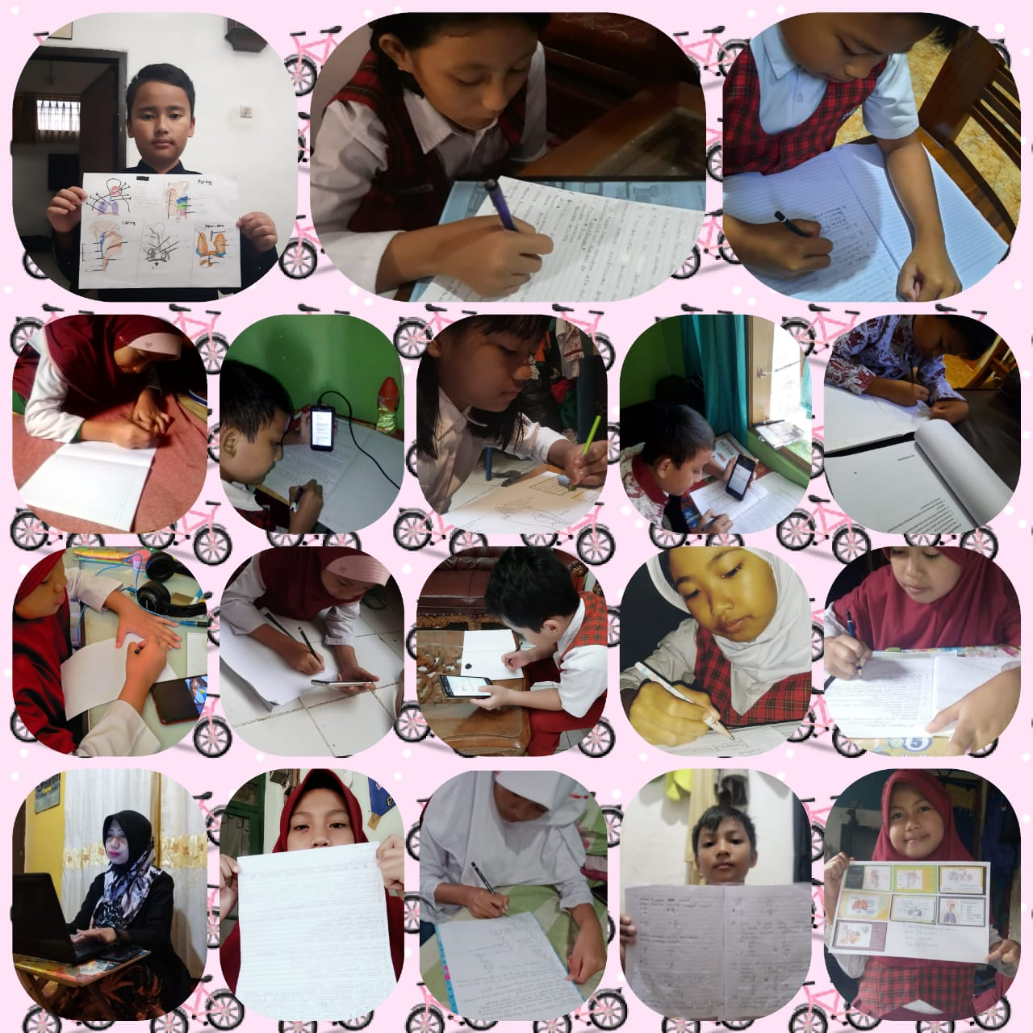
Picture 1
Students with the results of their respective performance

The picture above shows the activities of teachers and students. These activities include online remote meetings as well as face-to-face meetings. Students convey the results of their performance related to making an experiment report text accompanied by pictures. The results of student completeness in fulfilling these competencies are as follows.
Table 5
Students' completeness in the observation report text material
Serial number | Name |  | Gender | Value | Completed / Unfinished | Absorption |  | Information
 |  |  |  |  |  | Number | Category
1 | Siswa | 1 | F | 90 | Completed | 90 | High | Enrichment
2 | Siswa | 2 | M | 78 | Completed | 78 | Moderate | Enrichment
3 | Siswa | 3 | M | 88 | Completed | 88 | High | Enrichment
4 | Siswa | 4 | F | 91 | Completed | 91 | Very high | Enrichment
5 | Siswa | 5 | F | 90 | Completed | 90 | High | Enrichment
6 | Siswa | 6 | F | 90 | Completed | 90 | High | Enrichment
7 | Siswa | 7 | F | 80 | Completed | 80 | Moderate | Enrichment
8 | Siswa | 8 | M | 80 | Completed | 80 | Moderate | Enrichment
9 | Siswa | 9 | F | 91 | Completed | 91 | Very high | Enrichment
10 | Siswa | 10 | M | 88 | Completed | 88 | High | Enrichment
11 | Siswa | 11 | M | 70 | Unfinished | 70 | Low | Remedial
12 | Siswa | 12 | F | 90 | Completed | 90 | High | Enrichment
13 | Siswa | 13 | M | 78 | Completed | 78 | Moderate | Enrichment
14 | Siswa | 14 | F | 90 | Completed | 90 | High | Enrichment
15 | Siswa | 15 | M | 80 | Completed | 80 | Moderate | Enrichment
16 | Siswa | 16 | F | 80 | Completed | 80 | Moderate | Enrichment
17 | Siswa | 17 | M | 88 | Completed | 88 | High | Enrichment
18 | Siswa | 18 | F | 88 | Completed | 88 | High | Enrichment
19 | Siswa | 19 | F | 92 | Completed | 92 | Very high | Enrichment
20 | Siswa | 20 | M | 70 | Unfinished | 70 | Low | Remedial
21 | Siswa | 21 | M | 80 | Completed | 80 | Moderate | Enrichment
22 | Siswa | 22 | M | 80 | Completed | 80 | Moderate | Enrichment
23 | Siswa | 23 | M | 78 | Completed | 78 | Moderate | Enrichment
24 | Siswa | 24 | M | 90 | Completed | 90 | High | Enrichment
25 | Siswa | 25 | F | 90 | Completed | 90 | High | Enrichment
26 | Siswa | 26 | F | 93 | Completed | 93 | Very high | Enrichment
27 | Siswa | 27 | F | 90 | Completed | 90 | High | Enrichment
28 | Siswa | 28 | M | 80 | Completed | 80 | Moderate | Enrichment
 |  |  |  |  |  |  |  | 26
Lowest Value |  |  |  | 70 |  | Remedial |  | 2
Average value |  |  |  | 85 |  | The number of students |  | 28
Total Value |  |  |  | 2373
Class Completeness (%) |  |  |  | 93 | Very high
Absorption Class (%) |  |  |  | 85 | High
Based on the table above, we can see that the lowest score is 70 and the highest score is 93. Students with complete categories are 26 students. Meanwhile, 2 of the 28 students must remedial. The data assessment ranges are as follows.
Value <25 = teaching materials | = | not good
Value <50 | = | Pretty good
Value <75 | = | Good
Value 75 -100 | = | Very good

The data also implicitly shows the effectiveness of the implementation of learning to write an observation report text using the blended learning method. In previous research with the experimental method, Fitri (2016: 92) said that students in the experimental group were in the high category, while in the control group the level of student learning motivation was in the medium category. Research using the experimental method was also conducted by Ningsih (2017: 162) which states that the learning ability of students who receive Blended Learning learning is not better than students who receive ordinary learning. However, in this qualitative study, this time it presents a single result from one class only. This condition is because it does not allow the research to be carried out experimentally during online distance learning. However, the significant results can be seen from the students' completeness in teaching the teaching material to write the observation report text.
The Indonesian language that is learned at the elementary school level, of course, has the same portion as other subjects and is related to one another. As revealed by Dewi (2019: 235) that science is one of the subjects that should be in the learning process, students are expected to be able to connect what they are learning with everyday situations. In line with this opinion, Indonesian is also a subject that connects text with other subjects, such as Science. In this study, it shows that by writing an observation report text, students have indirectly learned about living things around them.
Conclusion
Learning scenarios are made for grade VI elementary school students for distance learning. The scenario is made for four meetings that combine online learning and face-to-face learning. Face-to-face learning is of course different from normal conditions in class. Therefore, in its implementation, the teacher visits students from house to house in turn and groups. The effectiveness of using blended learning in the text material of the observation report for grade VI elementary schools can be seen based on the results of student performance on these competencies. The students' absorption of the material is quite high, reaching 85%. Of the 28 students who were sampled, only 2 had to participate in the remedial. Class completeness is also very high, at 93%.
References
Amin, A. K. (2017). Kajian Konseptual Model Pembelajaran Blended Learning berbasis Web untuk Meningkatkan Hasil Belajar dan Motivasi Belajar. Jurnal Pendidikan Edutama, 4(2), 51-64.

Dewi, N. P. E. P., Sutama, I. M., & Sriasih, S. A. P. (2015). Analisis penerapan model pembelajaran problem based learning dalam pembelajaran menulis teks laporan hasil observasi kelas X IIS. 1 SMAN 1 mendoyo. Jurnal Pendidikan Bahasa dan Sastra Indonesia Undiksha, 3(1).

Dewi, S., & Kelana, J. B. (2019). Meningkatkan Kemampuan Berpikir Kreatif IPA Siswa Sekolah Dasar Menggunakan Model Contextual Teaching and Learning. COLLASE (Creative of Learning Students Elementary Education), 2(6), 235-239.

Fitri, E., Ifdil, I., & Neviyarni, S. (2016). Efektivitas layanan informasi dengan menggunakan metode blended learning untuk meningkatkan motivasi belajar. Jurnal Psikologi Pendidikan dan Konseling: Jurnal Kajian Psikologi Pendidikan dan Bimbingan Konseling, 2(2), 84-92.

Juliawati, N. K., Sutama, I. M., & Gunatama, G. (2015). Pembelajaran menulis teks laporan hasil observasi berbasis kearifan lokal pada siswa kelas VII A4 SMP Negeri 1 Singaraja. Jurnal Pendidikan Bahasa dan Sastra Indonesia Undiksha, 3(1).

Kosasih, E. (2016). Jenis-Jenis Teks dalam Mata pelajaran Bahasa Indonesia SMA. MA/SMK/MAK. Bandung: Yrama Widya.

Ningsih, Y. L., Misdalina, M., & Marhamah, M. (2017). Peningkatan Hasil Belajar dan Kemandirian Belajar Metode Statistika Melalui Pembelajaran Blended Learning. Al-Jabar: Jurnal Pendidikan Matematika, 8(2), 155-164.

Nurhayati, E., Sapdiani, R., Sudrajat, R. T., & Farihah, Z. L. (2019). Pengaruh Tabungan Literasi Terhadap Pembelajaran Menulis Teks Tanggapan di Sekolah Menengah Pertama Negeri 2 Cimahi. Diglosia: Jurnal Pendidikan, Kebahasaan, dan Kesusastraan Indonesia, 3(2).

Prasetyo, B., & Baehaqie, I. (2017). Pengembangan Media Video Animasi Untuk Pembelajaran Memproduksi Teks Laporan Hasil Observasi. Jurnal Pendidikan Bahasa dan Sastra Indonesia, 6(2), 41-47.

Purnomo, A., Ratnawati, N., & Aristin, N. F. (2017). Pengembangan Pembelajaran Blended Learning Pada Generasi Z. Jurnal Teori dan Praksis Pembelajaran IPS, 1(1), 70-76.

Sapdiani, R. (2019). Implementasi Model Pembelajaran Role Playing dalam Meningkatkan Kemampuan Menulis Teks Prosedur Pada Siswa Kelas VII Sekolah Menengah Pertama (SMP). Jurnal Akrab Juara, 4(1), 29-40.

Sjukur, S. B. (2012). Pengaruh blended learning terhadap motivasi belajar dan hasil belajar siswa di tingkat SMK. Jurnal pendidikan vokasi, 2(3).

Sugiyono. (2016). Metode penelitian: kuantitatif, kualitatif, dan R&D. Bandung: Alfabeta.

Wardani, D. N., Toenlioe, A. J., & Wedi, A. (2018). Daya tarik pembelajaran di era 21 dengan Blended Learning. Jurnal Kajian Teknologi Pendidikan, 1(1), 13-18.

