PROBLEMATIC ANALYSIS OF DIGITAL-BASED INDONESIAN LANGUAGE AND LITERATURE LEARNING IN THE PANDEMIC COVID-19 PERIOD
Author-name¹, Author-name², Author-name³

¹ Haerul, Khairun of University, Ternate
² Yusrina, Khairun of University, Ternate
¹ erul.peil@gmail.com, ² rina7432@gmail.com

Abstract

The presence of Covid-19 has affected various aspects of life around the world. One aspect that is greatly affected by this virus is the aspect of education. Digital-based distance education is one of the policies carried out by the government in Indonesia so that education continues. However, in the actualization of digital-based learning, there were many complaints from various groups, especially from students. The purpose of this study was to analyze the problems of digital-based learning during the Covid-19 pandemic. The object used as a source of data analysis in this study is the problem of learning Indonesian language and literature. This research was conducted using a qualitative descriptive method, which describes the problems experienced by students when participating in digital-based Indonesian language and literature learning. The results of this study indicate that digital-based learning problems are found from various aspects, both from lecturers, students, and aspects of the digital-based learning media used. Description of digital-based learning problems during the pandemic as a result of this research is very useful for the development of teaching creativity and it can be concluded that various aspects of digital-based learning still need to be improved and developed.
Keywords: Learning Problems, Digital Based Learning, Indonesian Language and Literature Learning, Covid-19

Abstrak

Kehadiran Covid-19 telah memengaruhi berbagai aspek kehidupan di seluruh dunia. Salah satu aspek yang sangat terdampak dengan adanya virus ini adalah aspek pendidikan. Pendidikan jarak jauh berbasis digital menjadi salah satu kebijakan yang dilakukan pemerintah di Indonesia agar pendidikan tetap berjalan. Namun, dalam aktualisasi pembelajaran berbasis digital tersebut banyak ditemukan keluhan dari berbagai kalangan, terutama dari mahasiswa. Tujuan penelitian ini adalah untuk menganalisis problematika pembelajaran berbasis digital di masa pandemic Covid-19. Objek yang dijadikan sebagai sumber data analisis dalam penelitian ini adalah problematika pembelajaran bahasa dan sastra Indonesia. Penelitian ini dilakukan dengan metode deskriptif kualitatif, yaitu mendeskripsikan problematika yang dialami mahasiswa ketika mengikuti pembelajaran bahasa dan sastra Indonesi berbasis digital. Hasil penelitian ini menunjukkan bahwa problematika pembelajaran berbasis digital ditemukan dari berbagai aspek, baik dari dosen, mahasiswa, maupun pada aspek media pembelajaran berbasis digital yang digunakan. Uraian problematika pembelajaran berbasis digital di masa pandemi sebagai hasil penelitian ini sangat bermanfaat bagi pengembangan kreativitas mengajar. Dapat disimpulkan bahwa berbagai aspek dalam pembelajaran berbasis digital masih perlu ditingkatkan dan dikembangkan. Dosen harus terus meningkatkan kreativitas mengajar, dan media pembelajaran masih perlu diperbaharui.
Kata Kunci: Problematika Pembelajaran, Pembelajaran Berbasis Digital, Pembelajaran Bahasa dan Sastra Indonesia, Covid-19

How to Cite: Last name-1, Initial First and Middle name-1., Last name-2, Initial First and Middle name-2., & Last name-3, Initial First and Middle name-3. (2017). Title Title Title Title. Semantik, X (X), XX-XX.

INTRODUCTION

Education is one of the aspects of life affected by the Covid-19 pandemic (Hapsari & Fitria, 2020). During the Covid-19 pandemic, the implementation of learning, including language learning, needs to adapt to changes to deal with existing learning problems (Rosidah, 2020). Learning media is part of learning that plays an important role in making it easier for learners to understand the material presented by the teacher or lecturer (Putri, 2019). Digital-based learning media can increase motivation and learning activities (Sucahyono, 2016). One form of digital-based learning media development is android-based learning (Oktiana, 2015; Efendi, 2018). Digital-based learning is also used in developing learning modules that are more effectively used in learning (Sugianto, et al., 2013; Dewi, 2015; Irwani, et al., 2017; Wira, et al., 2017). However, digital or technology-based learning media are still rarely used in the lecture process (Mulyaningsih, 2017).

Digital-based distance learning during the Covid-19 pandemic requires learners to prepare their own learning (Sadikin & Hamidah, 2020). Digital-based learning is one of the learning solutions during the Covid-19 pandemic. Digital-based learning is able to solve problems in learning (Ratri, 2018; Wijayawati, et al., 2019). However, on the other hand, there are still many complaints regarding the use of this learning media. Online learning during the pandemic is inseparable from learning problems (Hapsari & Fitria, 2020; Jamaluddin, et al., 2020; Kusumaningrum, et al., 2020). One of the problems in digital-based online learning during the pandemic is that mastery of technology is still low (Mulawarman, 2020). The purpose of this study is to describe the problems faced by students in the learning process of Indonesian language and literature using digital learning media.

METHOD

This research was conducted using a qualitative descriptive analysis method. Through this method, researchers analyzed and described the problems of learning digital-based Indonesian language and literature during the Covid-19 pandemic. The use of qualitative descriptive analysis research methods is described as follows.
- Collecting data and information needed about digital-based learning images using a questionnaire. The questionnaire was compiled and distributed via google questionnaire.
- Identify existing problems and analyze in depth using the perspective of blended learning theory.
- Interpret the factors that cause problems in digital-based learning.
- Provide recommendations related to things that need to be done in addressing problems in digital-based learning.

RESULTS AND DISCUSSION

Results

As the object of this research, there are several aspects that are the focus of analysis to obtain research data, namely: 1) Digital learning media used during the pandemic; 2) Audio quality from digital-based learning media; 3) The visual quality of digital-based learning media; 4) Quality videos from digital-based learning media; and 5) Internet network quality in implementing digital-based online learning.

1. Digital learning media used during the Covid-19 pandemic
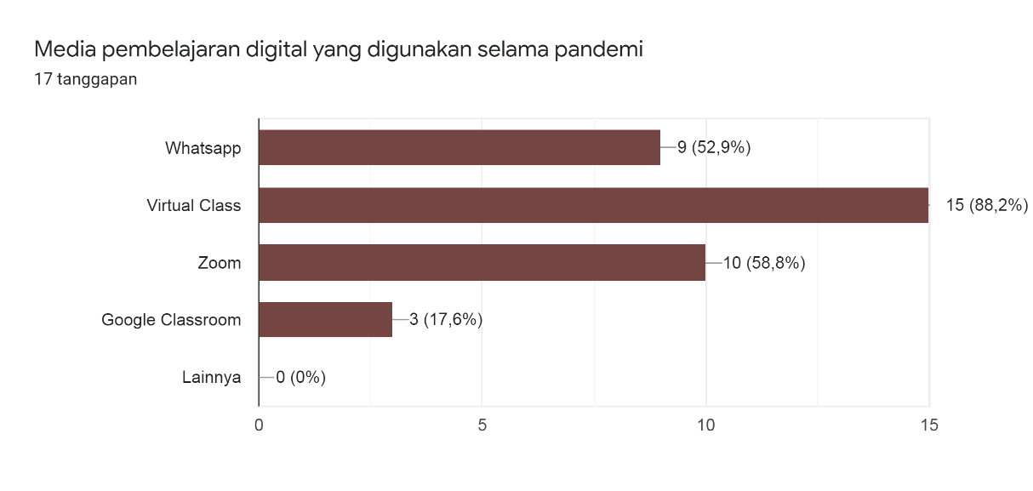
Based on this diagram, it can be seen that the media or application that is most widely used in digital-based Indonesian learning is virtual class learning media. Virtual class is a learning media prepared by Khairun University in order to facilitate and mediate the learning process during the Covid 19 pandemic. In addition, several other learning applications are also used, such as WhatsApp, zoom, and google classroom.

2 Audio quality from digital-based learning media

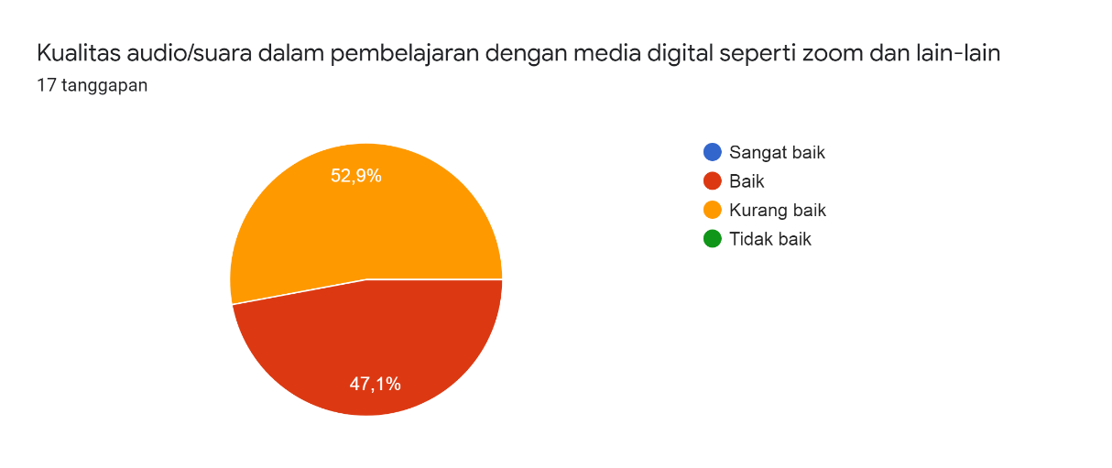
The diagram shows that the audio quality in the digital-based Indonesian language learning process is still not good. This is based on the assessment of about 52.9% of students who take part in the learning.

3. The visual quality of digital-based learning media
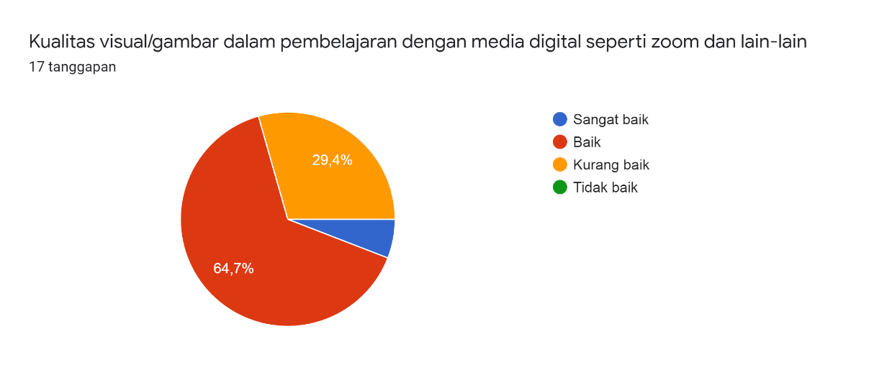
Based on the diagram, it can be seen that the visual or image quality in digital-based Indonesian learning is good. This is based on the assessment of about 64.7% of students who take part in the lesson.

4. Kualitas video dari media pembelajaran berbasis digital
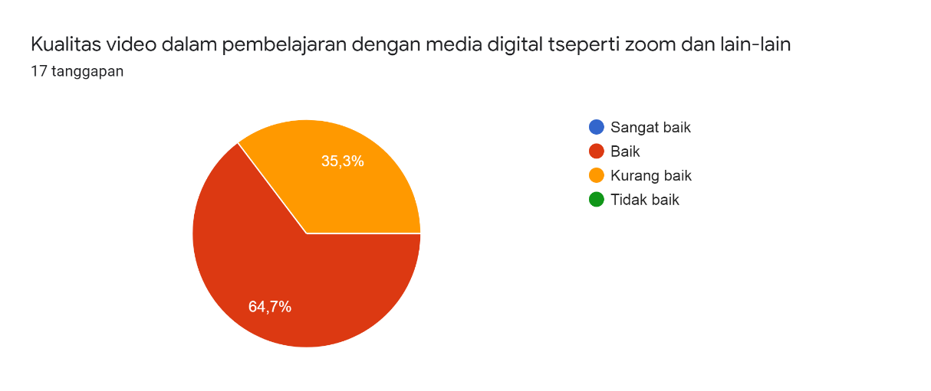
Based on the diagram, it can be explained that about 64.7% of students think that the quality of video in digital-based Indonesian learning is good and 35% of students think that the quality of the video is still not good.

- The quality of the internet network in the implementation of digital-based online learning.
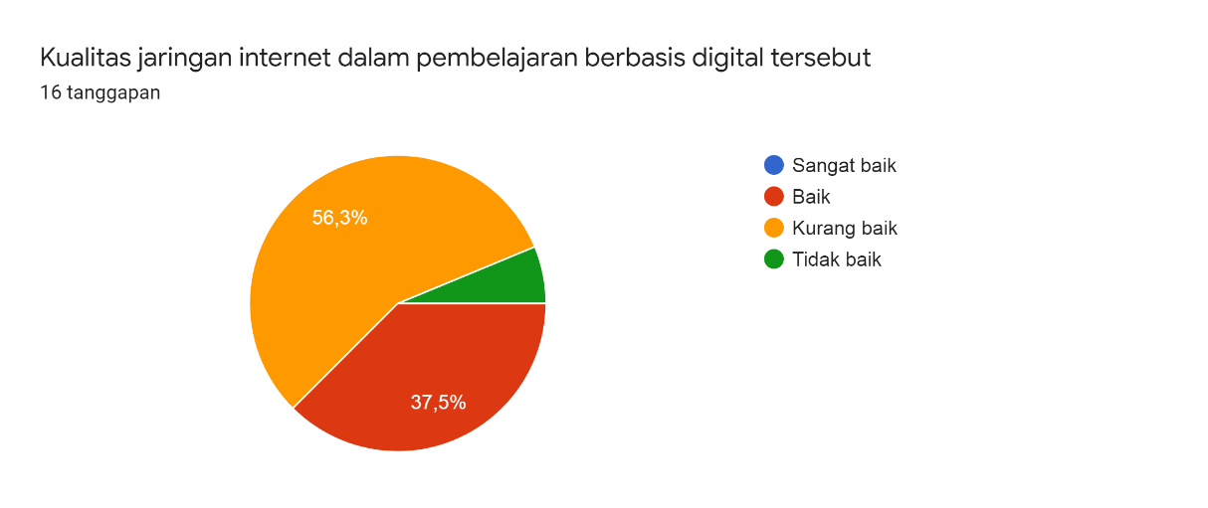
The diagram shows that the quality of the internet network in digital-based Indonesian language learning is still not good. This is based on the assessment of about 56.3% of students who take part in the learning.

Discussion

Based on the results of this study, it can be explained that the digital-based learning media that were widely used in learning Indonesian language and literature during the Covid-19 pandemic were virtual class learning media, zoom applications, and whatsapp applications. There are several problems found from the use of these learning media, namely poor internet access, ineffective teaching due to unclear voices so that students do not understand lecture material. The internet network that is not good causes the zoom application to always get error and sometimes the virtual learning media cannot be accessed.

In distance learning during the pandemic, almost every student only uses a cellphone to participate in learning. There are still many students who don't have laptops. This is also one of the problems in digital-based learning. Distance learning using mobile phones is more complicated when compared to distance learning using laptops. From these problems, many students recommend implementing face-to-face learning. Some students said that in a pandemic situation, if the learning media that is relied on is digital-based learning media, what needs to be paid attention to is the availability of a good internet network. If the internet network experiences interference, the sound and picture quality will also be affected.

Students hope that the lecturer will provide policies regarding the time for collecting lecture assignments. Lecturers must be able to understand and understand the conditions of students during a pandemic. Students suggest that lecturers use learning applications that are easy to use by students and do not require a lot of internet quota.

CONCLUSION

Based on the description of the results and discussion of this research, it can be concluded that the main problem in learning digital-based Indonesian language and literature during the Covid-19 pandemic was internet network access. The poor internet network then has an impact on various other aspects of learning, such as the clarity of sound, images, and videos in learning interactions. Internet network problems also cause students difficulty in sending assignments to lecturers.

ACKNOWLEDGMENTS

We would like to thank the Indonesian language and literature education program IKIP Siliwangi for holding a national seminar on literacy and language learning. The seminar became a forum for us to convey and express our research ideas.

REFERENCES

Dewi, F. (2015). Proyek Buku Digital: Upaya Peningkatan Keterampilan Abad 21 Calon Guru Sekolah Dasar Melalui Model Pembelajaran Berbasis Proyek. Metodik Didaktik: Jurnal Pendidikan Ke-SD-An, 9(2).

Efendi, N. M. (2018). Revolusi Pembelajaran Berbasis Digital (Penggunaan Animasi Digital Pada Start Up Sebagai Metode Pembelajaran Siswa Belajar Aktif). Habitus: Jurnal Pendidikan, Sosiologi, & Antropologi, 2(2), 173-182.

Hapsari, T. P. R. N., & Fitria, A. S. (2020). Efektivitas Pembelajaran Daring Mata Kuliah Evaluasi Pengajaran Bahasa Dan Sastra Indonesia Masa Pandemi Covid-19. Jurnal Ilmiah Semantika, 2(01).

Irwandani, I., Latifah, S., Asyhari, A., Muzannur, M., & Widayanti, W. (2017). Modul digital interaktif berbasis articulate studio’13: pengembangan pada materi gerak melingkar kelas x. Jurnal Ilmiah Pendidikan Fisika Al-Biruni, 6(2), 221-231.

Jamaluddin, D., Ratnasih, T., Gunawan, H., & Paujiah, E. (2020). Pembelajaran daring masa pandemik Covid-19 pada calon guru: hambatan, solusi dan proyeksi. LP2M.
Kusumaningrum, B., & Wijayanto, Z. (2020). Apakah Pembelajaran Matematika Secara Daring Efektif?(Studi Kasus pada Pembelajaran Selama Masa Pandemi Covid-19). Kreano, Jurnal Matematika Kreatif-Inovatif, 11(2), 139-146.

Mulawarman, W. G. (2020, May). Persoalan Dosen dan Mahasiswa Masa Pandemik Covid 19: Dari Gagap Teknologi Hingga Mengeluh Boros Paket Data. In Prosiding Seminar Nasional Hardiknas (Vol. 1, pp. 37-46).

Mulyaningsih, N. N., & Saraswati, D. L. (2017). Penerapan Media Pembelajaran Digital Book Dengan Kvisoft Flipbook Maker. Jurnal Pendidikan Fisika, 5(1), 25-32.

Oktiana, G. D. (2015). Pengembangan media pembelajaran berbasis android Dalam bentuk buku saku digital untuk mata pelajaran Akuntansi kompetensi dasar membuat ikhtisar siklus Akuntansi perusahaan jasa di kelas xi man 1 Yogyakarta tahun ajaran 2014/2015. Skripsi tidak diterbitkan (online). Yogyakarta: Jurusan Pendidikan Akuntansi Universitas Negeri Yogyakarta.

Putri, A. R., & Muzakki, M. A. (2019). Implemetasi Kahoot Sebagai Media Pembelajaran Berbasis Digital Game Based Learning Dalam Mengahadapi Era Revolusi Industri 4.0. In Prosiding Seminar Nasional “Penguatan Muatan Lokal Bahasa Daerah sebagai Pondasi Pendidikan Karakter Generasi Milenial”. Kudus (Vol. 20).

Ratri, S. Y. (2018). Digital Storytelling Pada Pembelajaran IPS di Sekolah Dasar. Jurnal Pena Karakter (Jurnal Pendidikan Anak dan Karakter), 1(1), 1-8.

Rosidah, I. (2020). Beradaptasi dengan Perubahan: Pembelajaran Bahasa dan Sastra di Masa Pandemi.
Sadikin, A., & Hamidah, A. (2020). Pembelajaran Daring di Tengah Wabah Covid-19:(Online Learning in the Middle of the Covid-19 Pandemic). Biodik, 6(2), 214-224.

Sucahyono, B. B. (2016). Analisa Efesiensi Penerapan Media Ajar Berbasis Digital Class pada SMPN 4 Pamekasan. Insand Comtech: Information Science and Computer Technology Journal, 1(1).

Sugianto, D., Abdullah, A. G., Elvyanti, S., & Muladi, Y. (2013). Modul virtual: Multimedia flipbook dasar teknik digital. Innovation of Vocational Technology Education, 9(2).

Wijayati, N., Kusuma, E., & Sumarti, S. S. (2019). Pembelajaran Berbasis Digital Di Jurusan Kimia Fmipa Unnes. Jurnal Inovasi Pendidikan Kimia, 13(1).

Wirasasmita, R. H., & Uska, M. Z. (2017). Pengembangan Media Pembelajaran Berbasis Buku Digital Elektronic Publication (Epub) Menggunakan Software Sigil pada Mata Kuliah Pemrograman Dasar. EDUMATIC: Jurnal Pendidikan Informatika, 1(1), 11-16.

